**HANOI UNIVERSITY OF SCIENCE AND TECHNOLOGY**

**MASTER’S THESIS**

**Research on automatic license plate recognition methods on edge devices**

**TrInh QuyEt TiEn**

Tien.TQ211262M@sis.hust.edu.vn

**Data Science**

|  |  |  |
| --- | --- | --- |
| **Supervisor:** | Ph.D. Pham Ngoc Hung | ____________________ Supervisor’s signature |
| **School:** | Information and Communication Technology | |

**HANOI, 04/2024**

**Graduation Thesis Assignment**

Name: Trinh Quyet Tien

Phone: +84354571869

Email: Tien.TQ211262M@sis.hust.edu.vn; quyettienraf@gmail.com

Class: 21A-IT-KHDL-E

Affiliation: Hanoi University of Science and Technology

Trinh Quyet Tien – hereby declare that this thesis, titled “Research on automatic license plate recognition methods on edge devices” is my personal work, which is performed under the supervision of Ph.D. Pham Ngoc Hung. All data used for analysis in the thesis are my own research, analysis objectively and honestly, with a clear origin, and have not been published in any form. I take full responsibility for any dishonesty in the information used in this study.

|  |  |
| --- | --- |
| Supervisor  Signature and Name | Student  Signature and Name |

**Acknowledgement**

To successfully complete the course topic, I would like to express my gratitude to Ph.D. Pham Ngoc Hung, School of Information Technology and Communication, Hanoi University of Science and Technology, for sharing invaluable knowledge, providing thorough guidance, and offering suggestions throughout the project so that I could complete the essay in the best possible manner.

After researching the topic and finishing the course, I have learned and accumulated knowledge and experience from my predecessors to improve and develop myself. Additionally, this has been an opportunity for me to realize what I need to enhance further to prepare for a long journey ahead.

Due to my limited knowledge and lack of practical experience, the research content inevitably contains shortcomings. I sincerely hope to receive feedback and further guidance from esteemed professors.

I sincerely thank you!

**ABSTRACT**

Automatic License Plate Recognition (ALPR) is a common problem that has attracted much research due to its wide application in real-world scenarios. Many studies have experimented with various methods and achieved impressive results, allowing for integration into specific applications. However, depending on the application context and specific requirements, the accuracy and processing capabilities of ALPR systems may vary. For example, recognizing license plates for vehicles entering and exiting parking lots with simple conditions (vehicles stationary within the frame, no need for rapid processing time) versus recognizing license plates for vehicles moving on highways or streets for law enforcement and traffic control purposes requires a more complex context (vehicles moving quickly, long distances). Furthermore, the increasing emphasis on edge computing has marked an important trend in ALPR system deployment, optimizing its performance and efficiency. With this development, selecting the right method for license plate recognition to suit specific application scenarios has become even more crucial. This study focuses on evaluating license plate recognition methods with the ultimate goal of optimizing them for deployment on edge devices.

License plate recognition methods vary depending on contextual conditions, and factors such as high vehicle speed, long distances, or unclear images pose challenges to identification and recognition. This can lead to reduced accuracy and the need for continuous evaluation and improvement to fit specific applications. Deploying license plate recognition processing on devices has the advantage of not requiring large image or video data transmission to servers, reducing the processing burden on servers. However, implementation on devices requires careful evaluation of performance and processing time. To address the challenges mentioned above, thorough evaluation of license plate recognition methods and optimization to meet performance and accuracy requirements on edge devices is necessary. The use of edge computing systems can address many issues by allowing data processing at the source without the need to transmit data to a centralized processing center far away. The result is reduced latency, increased processing speed, reduced network bandwidth usage, and data storage costs. Furthermore, edge computing systems are capable of operating independently and ensuring high availability, even when network connections are disrupted. Therefore, applying edge computing systems to the license plate recognition problem will improve system performance and reliability.

|  |  |
| --- | --- |
|  | Student  Signature and Name |

TABLE OF CONTENTS

CHAPTER 1: INTRODUCTION 11

1.1. Overview 11

1.2. Research Objectives 12

1.3. Research Motivation 12

1.4. Research Methodology 13

1.5. Thesis Organization 14

CHAPTER 2: RELATED WORKS 15

2.1. Overview of license plate recognition approaches 15

2.2. License plate detection 16

***2.2.1.*** ***Methods based on features extraction by image processing*** 16

***2.2.2.*** ***Methods based on deep learning*** 21

2.3. Character segmentation on license plate 25

2.4. Lincense plate characters recognition 29

Chapter 3: Methodology for license plate recognition 34

3.1. Data preparation 34

***3.1.1.*** ***Building dataset of Vietnamese license plate*** 34

***3.1.2.*** ***Increasing the diversity of dataset*** 38

3.2. Proposed method for license plate recognition 42

***3.2.1.*** ***Solution overview*** 42

***3.2.2.*** ***License plate detection*** 43

***3.2.3.*** ***License plate recognition*** 44

3.3. Optimal improvements 50

***3.3.1.*** ***Modifying model architecture*** 50

***3.3.2.*** ***Preprocessing input image*** 51

Chapter 4: Evaluating method on edge device 56

4.1. Implementing the method on edge device 56

***4.1.1. Introduction to Edge Device*** 56

***4.1.2. System architecture overview*** 57

***4.2.2. Vehicle control flow diagram at the parking lot*** 59

4.3. Performance evaluation on edge device 60

***4.3.1 Processing Performance*** 60

***4.3.2 Accuracy*** 60

CHAPTER 5: CONCLUSION 62

5.1. Summary 62

5.2. Future Work 62

REFERENCES 63

APPENDIX 01 70

**LIST OF FIGURES**

Figure 1. Basic steps of a license plate recognition system 15

Figure 2. Overview architecture of the integrated license plate recognition model 16

Figure 3 The development of YOLO 22

Figure 4 Yolov8 Architecture 24

Figure 5 Framework of the proposed PP-OCRv3 33

Figure 6. Types of vehicle license plate in Vietnam 34

Figure 7. Building a Vietnamese license plate datase 36

Figure 8. Distribution of each character in the data set 37

Figure 9. Diversify the data set by changing its size 38

Figure 10. Resize license plate 39

Figure 11. Increase/decrease the value of the luminance channel in the HSV color space 40

Figure 12. Rotate photos to random angles 41

Figure 13. Solution overview 42

Figure 14 The YOLOv8 model detects license plates 44

Figure 15. The straight lines are found by the algorithm 45

Figure 16. Take the longest line and rotate it according to the angle created by that line and the edge of the bounding box 46

Figure 17 License plate characters recognition 47

Figure 18. Deep Cosine Metric Learning model 50

Figure 19. Evolution of validation set accuracy 51

Figure 20. Gray-scale images are processed through the Histogram Equalization algorithm 53

Figure 21. Intensity distribution of the image after Histogram Equalization processing 53

Figure 22. Images are processed through filters 55

Figure 23 Raspberry Pi 4 57

Figure 24 System architecture overview 58

Figure 25 Vehicle control flow diagram at the parking lot 60

**LIST OF TABLES**

Table 1 The results of the license plate detection module 51

Table 2 The results of license plate extraction 57

Table 3 Some popular noise filters in image processing 66

Table 4 Results after applying the Histogram Equalization method 69

Table 5 Results after applying the Gaussian Blur 69

Table 6 Processing speed evaluation table of the method used on Raspberry Pi 4 77

Table 7 Table to evaluate the accuracy of the method used on Raspberry Pi 4 77

**LIST OF ACRONYMS**

|  |  |
| --- | --- |
| **Notation** | **Description** |
| CNN | Convolutional Neural Network |
| RNN | Recurrent Neural Network |
| SIFT | Scale-invariant feature transform |
| HOG | Histrogram of oriented gradient |
| SVM | Support Vector Machine |
| SSD | Single Shot Detector |
| YOLO | You Only Look Once |
| CER | Character Error Rate |
| OCR | Optical character recognition |
| ALPR | Automatic License Plate Recognition |

# **CHAPTER 1: INTRODUCTION**

* 1. **Overview**

In the era of continuous development in information technology, the problem of license plate recognition has become an increasingly important and challenging field of research. Since the early years of the 21st century, with the explosion of image processing methods and machine learning algorithms, license plate recognition has evolved from a purely research topic to a practical application with real-world significance. The applications of license plate recognition encompass traffic management, automatic toll collection, security and access control in industrial zones, parking lots, and many other areas.

The development of solutions and technologies in this field also takes place in a diverse and rich manner. From traditional image processing to the application of sophisticated algorithms, each approach brings in-depth insights and remarkable results.

The problem of license plate detection and recognition has long been a focus of research in the field of computer vision. However, with the powerful development of deep learning methods, a new approach to this problem has emerged. Neural networks in deep learning, such as Convolutional Neural Networks (CNNs), Recurrent Neural Networks (RNNs), along with network architectures like LeNet, ImageNet, Fast R-CNN, etc., are becoming increasingly popular and used in many practical applications. Particularly, the results achieved through competitions and research in the academic community have been highly impressive. These methods contribute to making license plate detection and recognition more accurate, faster, and more efficient.

Different license plate recognition methods have varying practical applications depending on the demanding contextual conditions. Factors such as fast-moving vehicles, long distances, poor image quality, etc., increase the complexity and pose challenges for license plate detection and recognition, reducing accuracy and necessitating analysis, evaluation, and improvement to fit specific applications.

Moreover, along with the strong development of recognition algorithms and computational capabilities, hardware performance is also increasing. The trend of performing processing directly on edge devices is becoming more common. Implementing license plate recognition tasks on edge devices helps avoid transmitting large image or video data to servers, reducing the processing load on servers. However, implementing on edge devices requires evaluations and responses regarding performance and processing time.

To address the above challenges, it is necessary to evaluate license plate recognition methods and optimize them for performance and accuracy on edge devices.

Using edge computing systems can improve the factors mentioned above because it allows processing data locally at the source without the need to transmit data to a centralized processing center located far away. As a result, it minimizes latency, increases processing speed, reduces network bandwidth usage, and data storage costs. Furthermore, edge computing systems can operate independently and ensure high availability, even when network connections are disrupted.

From there, the application of edge computing to the automotive identification issue will help improve the performance and reliability of the system. This not only opens up new approaches, but also proposes challenges in optimizing both software and hardware. Therefore, the topic is aimed at researching and evaluating methods for identifying vehicle stamps, with a particular focus on optimizing the performance of these methods when applied to border devices. Thus, the subject not only contributes to the treasury of academic knowledge but also towards practical applications, meeting the real needs of modern society.

* 1. **Research Objectives**

The thesis focuses on evaluating and improving the methodology of automatic license plate recognition methods on edge devices. It is structured around three primary goals:

* Research about the existing methods for detecting and recognizing vehicle license plates.
* Conduct tests and evaluations on license plate recognition methods using a collection of Vietnamese registration datasets to determine the most effective model in terms of performance and accuracy.
* Implement and assess the chosen recognition model and its processing application on an edge device, specifically a Raspberry Pi 4.
  1. **Research Motivation**

The method proposed in the topic can be applied in many applications, such as automated traffic monitoring, smart parking, automated charging stations, and many more. Using this method can help reduce human time and effort, while reducing traffic jams and increasing traffic convenience. One of the important factors for achieving high effectiveness of the method is to build accurate, diverse and relevant data sets in Vietnam. Applications developed from this method will benefit society and contribute to improving the quality of life of people.

The theme contributes to a new method of effective vehicle marking detection and recognition, with the aim of increasing accuracy and solving the existing problems of the previous methods. This research could provide a basis for future domestic studies, especially in the field of application of border devices. The accurate, diversified and real-life data set is also seen as a significant contribution to this study.

In this topic, the data set used to train and test the model will mainly consist of horizontally captured, undisguised, undamaged, painted, rusted and blurred, low-deformation carnet images. This ensures the quality of the data required for the identification process. The location of the camera for collecting images can be fixed or portable, with not too large angles of deviation, to ensure the stability and accuracy of the data obtained. Within the scope of the subject, only use motorcycle and automotive stamps common in Vietnam, in accordance with Circular 24/2023/TT-BCA on the size, symbols and layout of the vehicle stamps. Vehicle stamps from other countries will not be considered in this study, to ensure their specificity and relevance to the application context in Vietnam.

Additionally, the research will delve into the exploration and application of techniques such as image processing, machine learning algorithms, and deep learning for data processing and analysis in license plate detection and recognition. These methods will be chosen for their effectiveness and practicality, particularly for deployment on edge devices. The primary goal is to assess and refine these identification methods to ensure they perform efficiently and accurately in real-world scenarios, where high speed and precision are crucial.

* 1. **Research Methodology**

The topic revolves around the research and development of a vehicle ID system on devices and is based on the following ideas:

* *Research into vehicle ID methods*: First, the project will conduct a survey of the methods that have been developed to identify the vehicle ID. This includes learning about traditional methods as well as modern methods based on machine learning and artificial intelligence. The thesis will examine the strengths and weaknesses of each method, assess their applicability in specific application situations and master knowledge of progress in this field.
* *Propose a best method for experimentation, evaluation*: Based on the results of the survey, the subjects will choose or suggest a vehicle ID method that is considered to be best for experimentation and evaluation. This selection will be based on a variety of factors, including accuracy, processing performance, customizability, and application in different situations. The thesis will also present why the chosen method or proposal is considered the best choice based on the objectives of the topic.
* *Deployment on edge devices, optimum in performance:* After the method is selected, the subject will proceed to deploy it on the border device. This includes optimizing methods to ensure the best performance on e devices with limited resources. The topic will look at elements such as processing resources, memory, and the ability to integrate into practical applications. It will also evaluate the performance of the system in identifying vehicle labels in different contextual situations, as discussed in the previous section.

In short, the topic will involve researching, selecting, and deploying a method of identifying a vehicle ID on a border device, optimizing its performance to meet the requirements of practical applications.

* 1. **Thesis Organization**

The report consists of five chapters, with Chapter 2 focusing on introducing studies related to license plate detection and recognition, alongside application solutions in this field. It also provides fundamental knowledge to lay the groundwork for proposed models. Chapter 3 evaluates methods for license plate recognition on edge devices, then presents a proposed method for detecting and recognizing license plates along with its evaluation results. Chapter 4 outlines an overall architecture for a vehicle management system at parking lots, discussing the operational effectiveness of the system. Chapter 5 summarizes the report and discusses future development potential, accompanied by a bibliography of the references used in the study.

# **CHAPTER 2: RELATED WORKS**

**2.1. Overview of license plate recognition approaches**

License plate recognition models often include a series of basic steps, from image collection to processing and analysis to produce final results. This process not only requires the ability to accurately identify and classify text, but also requires addressing challenges from the external environment, such as image blur, lighting conditions, and other factors. other interference factors. Normally, the problem of vehicle license plate recognition includes the following basic steps:

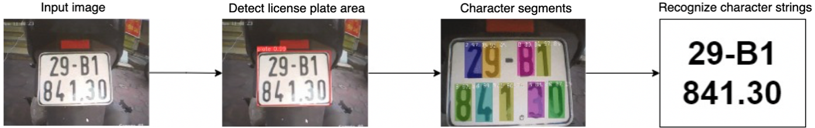

Figure 1. Basic steps of a license plate recognition system

From the above steps, there are three main steps in the license plate recognition process: detecting the license plate area, segmenting characters in the license plate, and detect character strings in the license plate. Based on recent research, the project finds that the approach to recognizing character strings on license plates without having to go through character segmentation is very potential, because it has many advantages. Therefore, the topic focuses on surveying works related to detecting the position of license plates and recognizing characters on license plates.

In addition, recent research also mentions the combination of processing both detection and recognition processes simultaneously, creating a more effective overall method to solve this problem. This method takes the idea of combining existing networks into a single network for detecting and recognizing license plates. The network architecture includes the following parts: network layer extracts low-level features, creates license plate areas, processes license plate areas, detects and recognizes license plates.

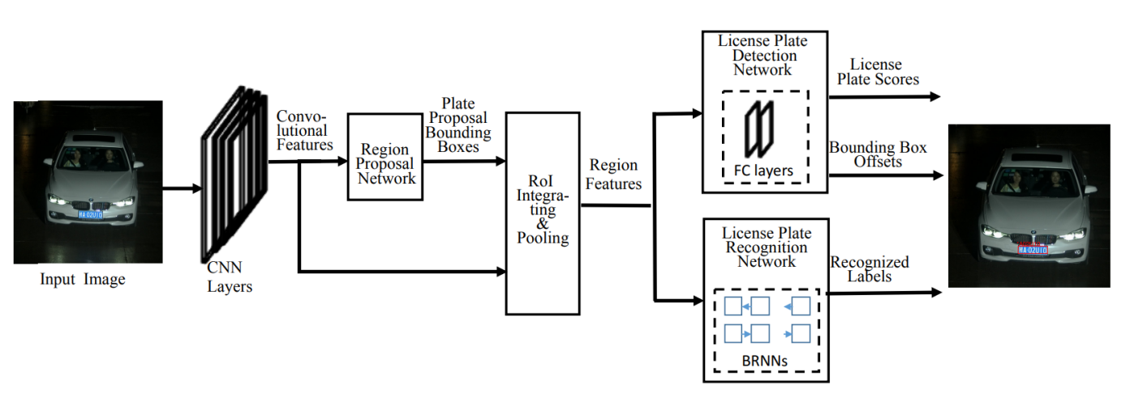

Figure 2. Overview architecture of the integrated license plate recognition model

In addition, the accuracy of license plate recognition also depends on the characteristics of the input data, license plate images collected from many different situations and conditions. Important characteristics of the data include:

* Condition conditions: This is a photo taken under normal conditions such as entering and exiting the parking lot, daytime, good natural light.
* Difficult conditions: This includes photos taken from a distance, in low light, or in various difficult situations such as rain, snow, or obscured by other objects.

This diverse data makes the model powerful and capable of recognizing license plates in many different real-life situations.

* 1. **License plate detection**
     1. ***Methods based on features extraction by image processing***

In the past, manual feature extraction methods were commonly used in image analysis. Commonly used features include basic features such as corners, edges, image grain, color and brightness level. Common methods to extract these features include image binarization, use of SIFT, HOG algorithms, connected component analysis, and morphology. Then, these features are passed through classifiers such as AdaBoost and SVM for classification.

Basic feature extraction methods are often simple, easy to implement and fast, especially when combining many features together, the results can achieve relatively high accuracy. However, these methods have the disadvantage of being quite sensitive to changes in brightness levels, noise, and blur. Furthermore, the design of the feature extractor depends a lot on the data set, so it is necessary to ensure that the data set is diverse enough to ensure the accuracy of the extraction method.

Below are some methods and articles using feature extraction methods in the field of image processing:

***A, License Plate Extraction using Boundary/Edge Information***

In the field of license plate recognition, many studies have focused on developing effective methods to identify license plate regions. A special method explored by many authors is to use edge and edge information to detect and extract license plates. The authors of the studies [1] [2] [3] [4] have contributed to this field through the methods they proposed. These methods include using Sobel filters to detect edges, combining vertical edges to create license plate rectangles, and using cubes to identify candidate license plate regions. Similar methods include using the Hough transform to detect straight lines and using the generalized symmetric transform (GST) to extract license plates. These studies have demonstrated that, through the application of image processing and morphological techniques, it is possible to significantly improve the accuracy in determining the location of license plates. Specifically, these methods leverage the power of edge and boundary detection to create robust cues about license plate locations, which enhances anti-interference capabilities and is suitable for license plate scenarios. has low contrast or is obscured.

However, despite many advantages, this method also encounters certain limitations. Edge-based algorithms are often sensitive to lighting variations, especially in situations where there are variations in light intensity or uneven lighting conditions, which reduces the likelihood of accurate recognition. Furthermore, handling cases where license plates are obscured by other objects also becomes difficult. In addition, this method requires complex and time-consuming calculations, especially when applied to real-time image/video processing, and cannot directly identify characters on license plates which requires a subsequent character recognition step.

Overall, the license plate extraction method using edge/boundary information can be very useful in many situations, especially when license plates have low contrast or in variable lighting conditions. However, it also has disadvantages and needs to be combined with other methods to ensure accuracy and efficiency in practical applications.

***B, Extract license plates using Global Image Information***

In the field of license plate extraction from images, applying Connected Component Analysis (CCA) on binary images is a popular method. Studies [5] [6] [7] [8] have applied and tested this method. CCA scans through the image and labels pixels based on their connectivity, using spatial features such as area and aspect ratio to filter and extract license plate areas. In addition, this technique also combines contour detection and 2D correlation to enhance license plate recognition. Although this method offers many benefits such as the ability to synthesize global information and good noise resistance, helping to minimize the influence of light variations and noise on the results, it also has some limitations significantly.

Disadvantages include high computational requirements due to the processing of global information of the image, leading to longer processing times, especially when applying deep machine learning algorithms. At the same time, the effectiveness of this method also depends largely on the quality of the image. Images with poor quality or strong noise can significantly reduce the accuracy of extraction. Additionally, in complex situations, such as when multiple license plates appear in the same frame or objects obscure the license plate, this method may have difficulty determining the exact location license plate location.

***C, Extract vehicle license plates using structural features***

Many studies focus on exploring and applying methods based on the structural characteristics and gray level changes of text on license plates. These methods exploit features such as texture, contrast, and spatial structure to determine the area containing the license plate. Below are some prominent methods:

* Scan-line Techniques: This method is based on analyzing gray level changes along scan lines, allowing the number of characters on the license plate to be detected when these changes are noted. A typical example is the study by Yang and Ma [9], which demonstrates effective detection based on morphology and mathematics.
* Vector Quantization - VQ: R. Zunino and S. Rovetta [10] used VQ to locate text in images, achieving a detection rate of up to 98% and a processing time of only 200ms, with an emphasis on efficiency and speed.
* Sliding Concentric Windows - SCW: Anagnostopoulos et al. [11] describe license plates as irregularities in image structure, using abrupt changes in local features to determine license plate positions.
* Gabor Filters and Fourier Transform (DFT): These methods, as described by Deb et al. [12] experimentally applied Gabor and DFT filters to determine the position and structure of license plates, although they require a lot of computation time.
* Wavelet Transform - WT: Hsieh et al. [13] used WT to extract license plates, taking advantage of the variation in vertical and horizontal edges, resulting in fast execution time and 97.33% accuracy.
* AdaBoost and Haar-like Features: Dlagnekov [14] combined AdaBoost with Haar-like features to build a powerful classifier that is insensitive to changes in brightness, color, size, and location of license plate.

General advantages of the "License Plate Extraction using Texture Features" methods include the ability to handle well in noisy situations and to be suitable for license plates with special structural features, thanks to their lack of dependence on color pixel color or intensity. Main disadvantages include the requirement of large data sets for efficiency, computational complexity, and difficulty in identifying unique texture features for license plates.

***D,* *License Plate Extraction using Color Features***

Research on the topic of license plate extraction has developed many color-based methods, taking advantage of the unique characteristics of license plate colors and characters on them. This method emphasizes the color difference between the license plate and the background, thereby determining the area containing the license plate. Some typical methods include using the HLS color model to classify pixels, applying a neural network after converting colors from RGB to HLS, using a genetic algorithm to determine color thresholds, and Apply Gaussian Weighted Histogram Intersection to improve detection efficiency under different lighting conditions.

The main advantages of this method include the ability to effectively recognize specific colors, the ability to detect license plates even if their shape is tilted or deformed, and high applicability in many countries. There are specific regulations on license plate colors. However, this method also faces limitations such as sensitivity to lighting conditions, difficulty in defining colors through RGB values, and the risk of errors in color classification, especially when The color of the license plate overlaps with the color of other parts of the vehicle. The following studies have contributed to this field:

* Shi et al. [15] explored the use of the HLS color model to classify each pixel into 13 color categories based on the specific format of Chinese license plates.
* Chang et al. [16] used a neural network to classify the color of each pixel after converting an RGB image to HLS. The colors of license plates in Korea are blue, red and white. Using a color variable edge sensor focuses on only three types of edges related to license plate color. The accuracy of locating license plates reached 97.9%.
* Yohimori et al. [17] applied Genetic Algorithm (GA) to determine the color of license plates. GA is used to determine upper and lower thresholds for license plate colors based on training with a variety of lighting conditions.
* Jia et al. [18] improved license plate detection using Gaussian Weighted Histogram Intersection (GWHI) to detect license plates by color matching. These methods modify the regular histogram using a Gaussian function to handle different lighting situations.
* Wan et al. [19] uses the color combination between license plate and character color to generate edge images. All edges in the new image are analyzed to find potential license plate regions.
* Deb and Jo [20] applied the HSI color model, the average values and standard deviations of colors were used to determine the pixels of blue and yellow license plates, as well as blue and yellow license plates. and white from the car's image.

Although color-based methods show high performance in license plate recognition, they require care in handling challenges related to lighting conditions and color classification. Further research and development may help alleviate these limitations, enhancing the applicability of the method in license plate recognition.

*E, License Plate Extraction using Character Features*

License plate extraction methods are based on identifying the characters of the license plate examining the image to find the presence of characters. If characters are found, their area is extracted as the license plate area. Some typical methods:

* Instead of using license plate attributes directly, the algorithm [21] tries to find all character-like regions in the image using a region-based method. These regions are then classified using a neural network, and if a linear combination of character-like regions is found, it assumes a complete license plate.
* Method [22] scans the image in the horizontal direction to find repeated contrast changes over a scale of 15 pixels or more. This assumes that the contrast between the characters and the background is good enough and that there are at least three to four characters with a minimum vertical size of 15 pixels. Achieve 99% accuracy in outdoor conditions.
* In the study [23] binary objects have the same aspect ratio as characters and have more than 30 labeled pixels. The Hough transform is applied to find lines, and the area between parallel lines with the number of objects between them similar to the number of characters is considered the license plate area.
* In [24] maximum stable extreme regions (MSER) are used to obtain a set of character regions. Dissimilar regions are eliminated, and the remaining regions with sufficient SIFT conversion points are retained as potential license plate regions.

The advantages of these methods include high accuracy in recognizing complete license plates and the ability to handle tilted or distorted license plates. However, they also suffer from a number of limitations such as being time consuming, the possibility of misidentification in the presence of other text, dependence on image contrast, and the need for memory and resources calculation principle.

* + 1. ***Methods based on deep learning***

Recent developments in computer vision have seen a significant shift from traditional statistical methods to deep learning neural networks, which offer higher accuracy in object detection. This trend is prominent in license plate detection, where various neural network models have been extensively utilized. Specifically, Selmi et al. have developed a localization method using a Convolutional Neural Network (CNN), as described in [25]. Their method involves initial image pre-processing to reduce noise and enhance detail, followed by the identification and classification of potential license plate areas with CNN classifiers. Tested on the Caltech dataset, their approach achieved impressive metrics with a recall of 93.8% and an f-score of 91.3%.

In another example, Zou et al. [26] implemented a dual-CNN strategy, employing both shallow and deep CNNs. The shallow CNN reduces background interference to lower computational demands, while the deeper CNN focuses on accurately detecting the license plate. This approach is further refined by non-maximum suppression (NMS) to accurately locate the license plate region, yielding above-average accuracy with reduced computational resources.

Moreover, the widespread adoption of advanced, real-time object detectors like the You-only-look-once (YOLO) [27] has significantly influenced license plate detection in recent ALPR studies. Furthermore, in challenging outdoor conditions, modifications to the standard YOLO models have been necessary. Gee-Sern et al. [28] have proposed a novel approach using YOLO and YOLO-9000 (YOLO-2) to adapt to variable weather and lighting conditions, enhancing the system’s ability to detect license plates in the wild.

Additionally, the work of Xie et al. [29] involves an advancement of the YOLO framework, now known as the MD-YOLO framework, which accommodates multi-directional detection and also provides information about the angle of rotation of the license plate. This model is especially effective in environments with poor illumination and occlusions, offering a significant improvement over the traditional methods.

***YOLO Model (You Only Look Once)***

The YOLO (You Only Look Once) model is a deep learning model used for object recognition in photos and videos. It is designed to recognize and classify objects simultaneously within a frame. The YOLO model uses a convolutional neural network to determine the location, size, and type of objects in an image and make predictions in real time. With high accuracy and fast processing ability, YOLO has become one of the most popular models in the field of object recognition. YOLO has appeared since 2015, and has developed through many versions, we can see the versions as shown in the Figure 7.

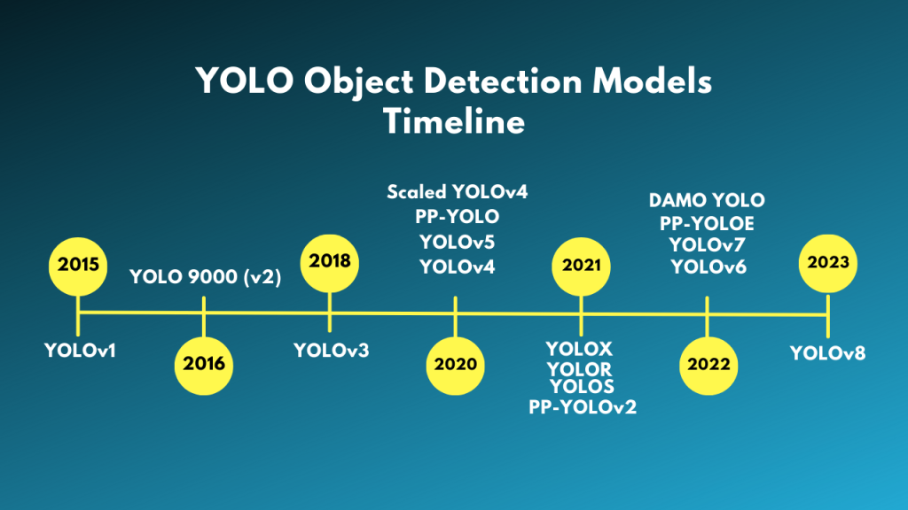

Figure 3 The development of YOLO

* YOLOv1: The first version of the YOLO model, which is YOLOv1 was published by Joseph Redmon et al. in 2015. This was the first single stage object detection (SSD) model that gave rise to the SSD models and all subsequent YOLO models.
* YOLOv2: also known as YOLO 9000 published by the original author of YOLOv1, Joseph Redmon. It improved YOLOv1 by introducing the concept of anchor boxes and a better backbone, which is Darknet-19.
* YOLOv3: In 2018, Joseph Redmon and Ali Farhadi published YOLOv3. YOLOv3 uses the Darknet-53 backbone, eliminating redundant connections, better pretrain and image enhancement techniques to deliver improvements.
* Ultralytics YOLO Object Detection Models: All YOLO object detection models up to YOLOv3 are written in the C programming language and use the Darknet framework. Beginners will have difficulty reading the code and fine-tuning the models. Around the same time as YOLOv3, Ultralytics released the first YOLO model (YOLOv3) implemented using the PyTorch framework. It is also more accessible and easier to use for transfer learning. Shortly after the publication of YOLOv3, Joseph Redmon left the Computer Vision research community. YOLOv4 (by Alexey et al.) is the last YOLO model written on the Darknet. After that there were many different YOLO models. Among them, YOLOv4, YOLOX, PP-YOLO, YOLOv6 and YOLOv7 are some prominent models. After YOLOv3, Ultralytics also released YOLOv5 which is even better, faster and easier to use than all other YOLO models. As of now, Ultralytics has published YOLOv8, which is probably the best YOLO model to date.

**YOLOv8**

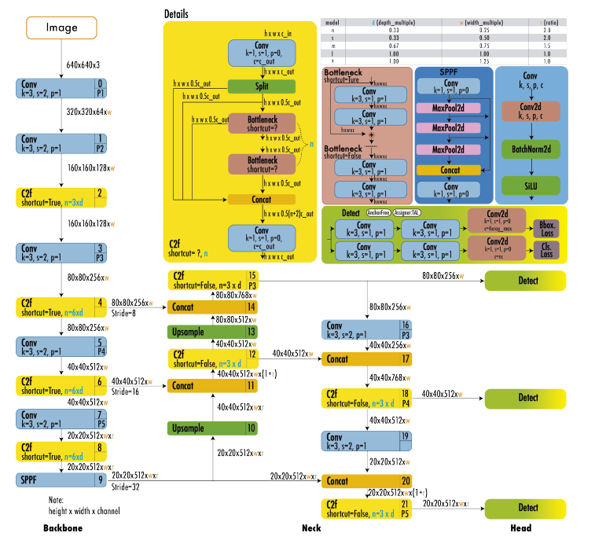

Figure 4 Yolov8 Architecture

YOLOv8 uses a similar backbone as YOLOv5 with some changes on CSPLayer, now known as the C2f module. The C2f module (inter-stage near coherence module with two convolutional layers) combines high-level features with context information to improve detection accuracy.

YOLOv8 uses an anchor-free model with an independent head to individually handle object, classification, and regression tasks. This design allows each branch to focus on its task and improves the overall accuracy of the model. In the output layer of YOLOv8, they use the sigmoid function as the activation function for the object confidence score, which represents the probability that the bounding box contains an object. YOLOv8 uses the softmax function for class probability, which represents the probability that an object belongs to each possible class.

YOLOv8 uses the CIoU and DFL [30] loss functions for the bounding box loss and the binary cross-entropy loss function for the classification loss. These losses improved object detection performance, especially when dealing with small objects.

YOLOv8 provides a semantic segmentation model called YOLOv8-Seg. Its backbone is the CSPDarknet53 feature extractor, followed by the C2f module instead of the classic YOLO neck architecture. The C2f module is followed by two segmentation heads, which learn to predict semantic segmentation masks for the input image. The model has similar detectors to YOLOv8, including five detection modules and one prediction layer. The YOLOv8-Seg model has achieved top results on many tests on object detection and semantic segmentation while maintaining high speed and performance.

Evaluated on the MS COCO test-dev 2017 dataset, YOLOv8x achieved an AP (Average Precision) of 53.9% with an image size of 640 pixels (compared to YOLOv5's 50.7% with the same head size in) at 280 frames per second on NVIDIA A100 GPU and TensorRT.

The YOLO model is famous for its fast processing speed. It has real-time image processing capabilities, suitable for applications that require agility such as self-driving cars, real-time video monitoring, and many others. YOLO uses a unique neural network to predict bounding boxes and classes of objects. This reduces model complexity and makes it easier to deploy and use. The YOLO model uses less resources than many other object detection models, especially when real-time image processing is needed on devices with limited resources. YOLO is capable of detecting multiple objects of different classes in a single evaluation, improving performance and accuracy.

However, compared to some complex object detection models, YOLO may not provide high accuracy in object detection, especially small or complex shaped objects. YOLO may have difficulty detecting objects that are close together or overlapping each other due to the mesh architecture and resolution limitations. To ensure performance and accuracy, YOLO needs a large training dataset, which requires a lot of annotation data and computational resources for effective training. YOLO can have difficulty detecting small objects, but its later versions have tried to improve this.

* 1. **Character segmentation on license plate**

***A, Data preprocessing***

License plates after being extracted may encounter some problems such as tilting and uneven brightness. Therefore, to increase accuracy, license plates need to be preprocessed before being included in segmentation algorithms. Some image preprocessing methods such as using the linear transformation method to convert the extracted license plate tilted into a straight rectangle [31], applying the least squares method to handle the error. Horizontal and vertical tilt in license plate images [32]. M.-S. Pan and colleagues [33] applied the Karhunen-Loeve (K-L) transform to organize the coordinates of characters into a two-dimensional multidimensional covariance matrix. The eigenvector and the rotation angle α are calculated sequentially. Then, make a horizontal skew adjustment of the image. For vertical tilt correction, three methods are proposed: using K-L transform, K-means clustering based fitting method and least squares based fitting to calculate the vertical tilt angle θ. K. Deb and colleagues [34] used least squares with perpendicular distance to adjust the tilt angle of the license plate horizontally. At the same time, adjust the vertical tilt by minimizing the fluctuation of the coordinates of the projection points. After horizontal skew adjustment, segmentation of the characters is performed and the coordinates of the characters are projected vertically after applying a symmetric clipping transform.

Choosing an inappropriate threshold for the binarization of extracted license plates can lead to characters being connected to each other, making the segmentation process difficult. These characters create difficulties in the segmentation process. For license plates with surrounding frames, after the binarization process, some characters may be connected to the frame, creating segmentation challenges. Improving image quality before binarization helps to choose an appropriate threshold. Commonly used methods to improve license plate images include noise removal, gray histogram equalization, and contrast enhancement. Following are some studies proposing to increase image quality. P. Comelli and colleagues [35] performed gradient analysis on the entire image to detect license plates, then license plates were optimized. transformed through gray level transformation. Y. Zhang, and C. Zhang [36] found that the size of the characters accounts for about 20% of the size of the license plate. First, the gray levels are scaled from 0-100, then the largest 20% of pixels are multiplied by 2.55. Only characters are optimized while noisy pixels are reduced. D. Llorens and colleagues [37] applied a local thresholding method to each pixel, in which the threshold is calculated by subtracting a constant c from the average gray level in an m×n window centered at that pixel. C. Coetzee and colleagues [38] calculated the threshold based on the Niblack binarization formula to transform the threshold based on the local mean and standard deviation.

***B, License Plate Characters Segmentation using Pixel Connectivity***

Segmentation is performed by marking connected pixels in a binary license plate image [7] [39]. The marked pixels are analyzed and those pixels with the same size and aspect ratio as the license plate characters are considered as license plate characters. However, this method fails to extract all characters when there are concatenated or disjointed characters.

This method relies on connecting pixels to segment license plates. This creates a simple and effective solution, especially for license plates with clear characters and not much noise, that can integrate image data to determine the location and borders of the vehicle license plate, works well in many cases when the license plate does not have connected or disconnected characters, the license plate image is not too noisy.

The method of segmenting license plates using Pixel connection has difficulty in segmenting license plates with connected or disjointed characters, the method may miss or incorrectly segment characters. If the license plate image has too much noise or has uneven light and dark spots, this method may not work effectively. Sometimes it is necessary to perform preprocessing steps to clean up the image before applying this method. This can add extra work and complexity to the license plate recognition process.

***C, License Plate Characters Segmentation using Projection Profiles***

Since the characters and the license plate background have different colors, they have opposite binary values in the binary image. Therefore, some proposed methods use vertical projection of the binary image of the license plate to determine the starting and ending positions of the characters, and then horizontal projection of the extracted characters. to separate individual characters.

In the study [40], the vertical projection method was used to extract characters, combined with noise removal and character sequence analysis. Through testing on more than 30,000 images, this method has achieved 99.2% accuracy with a processing speed of 10-20ms.

In [41] and [43], character color information is used in the projection process instead of using the binary image of the license plate. In total, based on research literature, the method using vertical and horizontal projection of pixels is the most popular and simple.

The projection method allows to extract characters on license plates without knowing their specific location in advance. This ensures the method is flexible and capable of handling license plates that may be rotated or shifted in the image. If installed and adjusted properly, the projection method can achieve high accuracy in extracting characters from license plates. Studies have shown that it can achieve an accuracy rate of up to 99.2% with fast processing speed. This method does not depend on the color of characters or license plates, which can help it work well in a variety of lighting and color situations.

However, there are some disadvantages such as the projection method relies on pixel values in the image, so it is sensitive to noise and poor image quality. If the license plate image is noisy or blurry, accuracy may be reduced. This method requires knowing in advance the number of characters on the license plate so that appropriate projections can be created. If the number of characters varies (for example, a license plate may have 7 or 8 characters), this method may encounter difficulties. Any noise in the image will affect the projection value, and may lead to incorrect character extraction.

***D, License Plate Characters Segmentation using Prior Knowledge of Characters***

In the study [43], the binary image was scanned by a horizontal line to find the starting and ending positions of the characters. When the ratio of the number of pixels of the characters to the background on this horizontal line exceeds a certain threshold, this is considered the starting position of the characters. The reverse scaling is done to find the ending position of the characters.

In the study [44], the extracted license plates were resized to a known sample size. In this sample size, all the positions of the characters are known in advance. After size adjustment, similar positions are extracted to form characters. This method has the advantage of simplicity. However, in case there is a change in the extracted license plate, the resulting extraction will be the background and not the characters.

In the study [45], the method proposed a solution for license plates of severely damaged vehicles. The color combination is used to determine the position of the license plate on the image. The size of each character is used to segment the characters. The structure of Chinese license plates is used to build a classifier for the identification process.

License plates in Taiwan all have the same color distribution of black characters on a white background. The paper [46] suggests that if license plates are scanned with a horizontal line, the number of transitions from black to white (or from white to black) is at least 6 and at most 14. Hough is used to correct tilt; The combined binarization technique is used to segment the characters in dirty license plates; and a feedback automatic learning process is used to adjust the parameters. In the experiment used a total of 332 different images taken under different lighting conditions and at different distances. The overall location and segment rates were 97.1% and 96.4%.

This method is capable of achieving high accuracy in segmenting license plate characters, especially when information about the starting and ending positions of the characters is available. This is especially useful when applied in automatic license plate recognition systems. This method uses information about the color of characters to determine their position in the license plate, helping to increase the reliability of segmentation, especially in cases where license plates have black characters on them. white background, as in the case of license plates in Taiwan. This method is often simple in deployment and implementation. Using prior knowledge about characters reduces complexity in the segmentation and recognition process.

However, the license plate segmentation method using Prior Knowledge of Characters requires prior knowledge about the location and nature of the characters in the license plate. This means that if there are variations or address changes in the license plate, segmentation can become ineffective and result in segmentation of the background instead of the characters. Any noise or variation in the image may affect the reliability of this method. This is especially true when using color-based methods. This method is often based on specific license plates or colors, so it may not be suitable for cases where license plates have different designs or colors.

***E, License Plate Characters Segmentation using Character Contours***

Contour modeling is also used for character segmentation. In [47], a shape-based active contour model was established, which used a variable fast migration algorithm. The system works in two steps. First, the approximate position of each character is found using a conventional fast traverse technique [48] combined with a rate function that depends on slope and curvature [49]. Then, the exact boundary is obtained by a special fast moving method.

The character border model helps determine the exact border of each character, providing high accuracy in the license plate segmentation process. Using a fast moving algorithm combined with a speed function that depends on slope and curvature creates flexibility that can be applied to many different conditions and license plate types. Using a fast movement algorithm enhances computational efficiency, especially in the step of determining the rough position of characters.

However, the process of determining the exact boundary requires detailed calculations and can increase the complexity of the model. To achieve good performance, the model needs to be trained on a large amount of highly diverse license plate data. Contour-based methods can become sensitive to lighting fluctuations, especially in low or contrasting lighting conditions.

* 1. **Lincense plate characters recognition**

During the character recognition process of the Automatic License Plate Recognition (ALPR) system, characters are extracted from license plate photographs and then processed for identification. This process faces some significant technical challenges. One of the main problems is due to the difference in size and thickness of the characters, which largely depends on the camera magnification factor, as shown in reference [35]. An effective solution to this problem is to standardize the size of characters before proceeding with the recognition process, to ensure consistency.

In addition, the variety of fonts also causes difficulty in the identification process due to differences in license plates between countries. Other problems include the presence of noise and damage on the extracted characters, as well as their tilting which further increases the complexity of the recognition process.

The next part of the article will focus on classifying modern character recognition methods, based on the specific characteristics they use to address these challenges.

1. ***Character Recognition using Raw Data***

In the field of character recognition, pattern matching is considered a basic and effective approach [42], [50]. This method is based on evaluating the degree of similarity between the extracted character and the standard samples. The character with the highest similarity to a given pattern is identified as the target character. Most studies on pattern matching choose to use binary images, because the colors in grayscale images can change due to the influence of lighting conditions [32]. Studies [35], [41], [50], [51], [52] performed the pattern matching process after normalizing the size of the extracted characters.

Many techniques for measuring similarity have been developed. Examples include the Jaccard value in [41], the Hausdorff distance in [52], and the Hamming distance in [50]. The work in [35] and [53] applies normalized cross-correlation to match the extracted character to the samples, thereby the sample with the highest cross-correlation value is determined as the best-matched sample.

Pattern matching is effective in character recognition as long as they have the same font, are not rotated, not broken, and have a fixed size. However, if the character has differences from the sample, such as font changes, rotation, or noise, this method may lead to inaccurate recognition results [32]. To solve the problem of recognizing tilted characters, the research in [54] proposed a solution to store multiple samples of the same character with different tilt angles.

The Character Recognition using Raw Data method is often based on simple techniques such as pattern matching, making it easy to understand and implement. Since it is often based on direct comparison with the original data, the recognition process can be performed quickly, especially when using binary images. When characters are normalized (same size, font, not rotated), this method can achieve high accuracy. This method does not require as many computational resources as machine learning or deep learning methods.

However, the Character Recognition using Raw Data method is less effective with characters that have variations in font, size, or are rotated or broken. This method can be affected by noise or changes in lighting conditions, reducing accuracy. It is not effective in recognizing characters with many variations such as handwriting or slanted characters. For variant characters, it is necessary to store many different patterns, which increases memory and data management requirements. This method is not suitable for applications that require character recognition in different conditions and environments.

Although the character recognition method using primitive data has the advantages of being simple and fast, it has limitations in handling character variations and is sensitive to exception conditions, causing it is not suitable for some complex or diverse applications.

1. ***Character Recognition using Extracted Features***

Since not all pixels in a character are equally important in distinguishing characters, applying feature extraction techniques from characters serves as an effective alternative to pattern matching techniques. based on gray levels [42]. This method reduces the processing time required for pattern matching by eliminating the use of all pixels. At the same time, it also solves the problems encountered in pattern matching, as long as the extracted features are strong enough to distinguish characters despite distortion [32]. These features are then synthesized into feature vectors and compared with stored feature vectors to evaluate the level of similarity.

In studies [42] and [55], feature vectors are created from projecting binary characters in horizontal and vertical directions. In the study [55], each projection is quantized into four levels. In [56], the feature vector is generated from the Hotelling transform of each character, a method that is sensitive to the segmentation results. In [57], dividing a binary character into 3x3 pixel blocks and counting the number of black pixels in each block also produces a feature vector. In [58], after performing the character thinning operation, the character is divided into 3x3 blocks and counts the number of elements with tilts of 0, 45, 90 and 135 degrees to create a feature vector. In [59], the method of scanning characters along the central axis, connecting the upper and lower horizontal central moments, is also applied. The amount of transition from character to background and the distance between them make up the feature vector, which is not affected by the rotation of the character. In [60], the feature vector is generated from sampling around character outlines, with the resulting wave shape quantized. This method is effective in recognizing multi-font and size characters. In [61], Gabor filter is used in the feature extraction process. In [62], applying Kirsch edge detection on character images in different orientations is also an effective method. In [63], feature vectors are extracted from binary character images by performing character thinning and then converting character strokes into an encoding. In [64], the gray values of pixels in 11 sub-blocks are used as features and fed into the neural network classifier. In [65], the scene is processed by visiting non-overlapping 5x5 blocks, processing surrounding image data to extract "scattered" edge features based on the study [66], and classifying the images This sub follows the coarse-to-fine search strategy described in [67]. In [68], three character features are used: border cross count, direction count, and peripheral background area, with classification performed using a support vector machine. In [16], topological features of characters including the number of holes, endpoints, three-way nodes and four-way nodes are used, these features do not change with spatial transformation.

After feature extraction, many classifiers can be used to recognize characters, such as ANN [64], SVM [69], HMM [37]. Some studies integrate two types of classifiers [70]-[71], multi-stage classifiers [72], or combine multiple classifiers in parallel [73].

In the field of optical character recognition (OCR), successive developments from PP-OCR to PP-OCRv2 and PP-OCRv3 by Baidu Inc. has marked great advances in improving the performance and accuracy of lightweight yet powerful OCR systems. PP-OCR, first introduced by [74], is an ultra-lightweight OCR system that uses strategies such as Differentiable Binarization (DB) and CRNN for text detection and recognition. Next, PP-OCRv2, as described by [75], offers a 'bag of tricks' to train a better text detection and text recognition model, including Mutual Cooperative Learning (CML), CopyPaste, and Lightweight CPU Network (PP-LCNet). Finally, PP-OCRv3 further upgrades both the text detection and recognition model, incorporating enhancements such as the PAN module with a wide field of perception (LK-PAN), the FPN module with a residual attention mechanism (RSE-FPN), and cooperative mutual learning (CML) strategy for text detection, along with the lightweight text recognition network SVTR-LCNet for text recognition [76]. These developments demonstrate progress not only in the field of text recognition but also in improving performance and reducing model size, suitable for real-world applications that require high performance and accuracy.

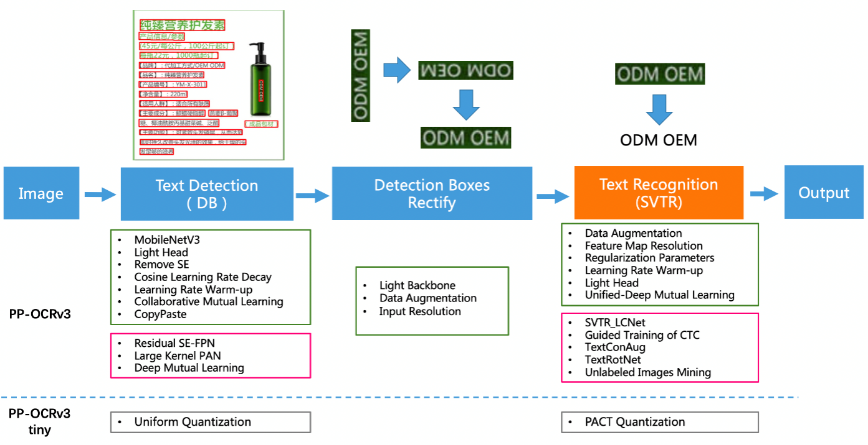

Figure 5 Framework of the proposed PP-OCRv3

By eliminating the use of all pixels in a character, this method significantly reduces the processing time and computational resources required for pattern matching. The extracted features often contain the most important information needed to distinguish between characters. This helps increase the accuracy of the identification process. This method is capable of recognizing characters in many different conditions and variations, such as size, font, and format. This method is less affected by noise or variations in lighting conditions compared to traditional methods. Can be combined with advanced classifiers such as artificial neural networks (ANN), support vector machines (SVM), and hidden Markov models (HMM) to improve results. This technique reduces processing time by eliminating consideration of all pixels, reducing computational load.

However, this method often requires more complex algorithms and more calculations than traditional methods. To achieve high performance, large training data and thorough fine-tuning are required. If the image segmentation process is not accurate, feature extraction may be ineffective, leading to inaccurate recognition results. Identifying and selecting important features for identification is not always obvious and may require deep expertise. The effectiveness of this method may vary depending on the type of character and language to be recognized.

# **Chapter 3: Methodology for license plate recognition**

* 1. **Data preparation**

In the research field related to license plate recognition, the lack of common data sets is a significant challenge. While there are some notable datasets such as CCPD [77], UFPR-ALPR [78], AOLP [79] and PKUData [80], they are often country-specific, with size and layout is not completely compatible with the Vietnamese environment. These data sets, while valuable, are not entirely suitable for training domestic license plate recognition systems. Therefore, the main data sources used in this topic will come from two directions: actual collection and automatic generation. Actual data collection will take place under a variety of conditions, including camera angles, lighting conditions, and camera resolution, to ensure diversity and reality of data set. This data set will then be divided into two parts: the training set, used to optimize the parameters of the recognition system, and the test set, used to evaluate the effectiveness of the method after the training process. Both data sets will be carefully labeled, including the location of the license plate and the identification of characters on the license plate. Thereby, ensuring that the system can be trained and evaluated effectively, accurately reflecting the actual conditions and characteristics of the traffic environment in Vietnam.

* + 1. ***Building dataset of Vietnamese license plate***



Figure 6. Types of vehicle license plate in Vietnam

Circular 24/2023/TT-BCA regulates the issuance and revocation of motor vehicle registration and license plates, with the following main points:

* Cars will be fitted with two license plates with different sizes and arrangements of letters and numbers for domestic and foreign agencies, organizations and individuals.
* Motorcycles are issued license plates mounted on the back of the vehicle, with the size and arrangement of letters and numbers distinguishing between domestic and foreign agencies, organizations, and individuals.
* The color and series of license plates distinguish between vehicles of domestic agencies, organizations and individuals and foreign organizations and individuals, with different background colors and letters and numbers.
* Special series symbols for vehicles such as commercial vehicles, specialized cars, military vehicles, tractors, and other vehicles with similar structures.
* Vehicles of diplomatic missions and international organizations have license plates with special colors and series of symbols.

Based on the regulations of Circular 24/2023/TT-BCA, depending on the type of vehicle, ownership organization, and territory, there will be separate regulations on the size, layout, and content of the sign. different numbers. However, let the driver only focus on common license plates of cars and motorbikes. In terms of size, license plates can be divided into two types: short license plates and long license plates. In terms of the total number of characters in a license plate, a normal license plate has 8 or 9 characters. Detailed regulations on license plates are quoted in Appendix 01.



Figure 7. Building a Vietnamese license plate datase

In this study, we introduce a unique dataset of license plate numbers, collected from many different online sources. The goal of creating this dataset is to provide a rich and diverse data source, supporting research and applications in the field of automatic license plate recognition.

The process of collecting the dataset includes searching and selecting license plate images from forums, websites and open databases on the internet. After each image is collected, it will be checked for quality and carefully labeled with information about the type of vehicle (motorbike or car) and the size of the license plate. Aimed at ensuring diversity and comprehensiveness, this dataset includes a wide range of license plate types, from popular motorbikes to personal and commercial cars, with many different sizes and formats.

After the collection phase, the entire dataset has been classified, labeled and statistically detailed, with the aim of providing a clear view of the structure and characteristics of the data. This dataset not only reflects the diversity of images, sizes and types of license plates, but also contains valuable information to help develop and test machine learning models in the field of automatic recogtition become more efficient.

Some information about the dataset:

- Total number of photos: 10210

- Number of license plates:

+ Motorcycle: 3984 (8 - 9 characters)

+ Car: 5734 (8 characters)

+ Other vehicles: military vehicles - 222 photos (6 characters) and diplomatic vehicles - 398 photos (9 characters)

- Total number of characters: 76372

- License plate includes the following characters: 0, 1, 2, 3, 4, 5, 6, 7, 8, 9, A, B, C, D, E, F, G, H, K, L, M, N, P, R, S, T, U, V, X, Y, Z

Details about the distribution of each character in the real data set:

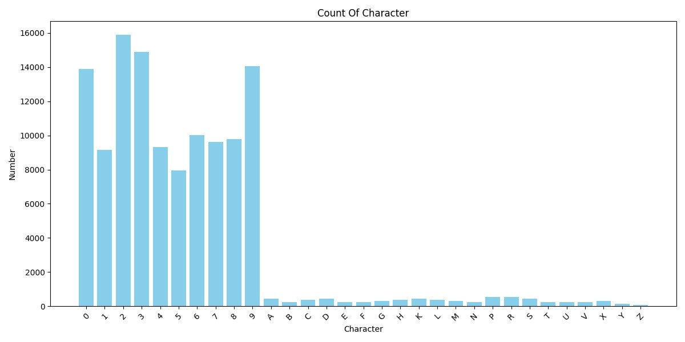

Figure 8. Distribution of each character in the data set

During the preparation of the data set for the study, each data sample was labeled with detailed information about the location and character content of the license plate. Spatial positioning of the license plate is done through determining the coordinates of the four corners that make up the license plate. This facilitates the conversion of these coordinates into a bounding rectangle, representing the area containing the entire license plate in the image. In particular, during the position labeling process, a necessary emphasis is placed on ensuring that the edges of the license plate remain within the rectangular boundary, in order to increase accuracy in identification and minimize the possibility of confusing license plates with other objects containing character strings. Regarding the character content on the license plate, the labeling process focuses on letters and numbers, while other auxiliary characters such as dash "-" and period "." is eliminated to streamline data and focus on the most basic and important information of the license plate.

* + 1. ***Increasing the diversity of dataset***

License plate images in the database have many images taken from a camera at the vehicle access control position in the tunnel. Therefore causing some problems:

- There is no diversity in the size of license plates, because the distance from the camera to the license plate is approximately equal between images.

- The photos have low brightness and are almost the same because the photos were taken in an apartment basement.

From there, we need a method to enrich the data set.

***A, Diverse sizes of license plates***

We can diversify the size in 2 ways:

- Method 1: Reduce the size of the sea by adding random size borders to the original image, then resize the image to the original image size.

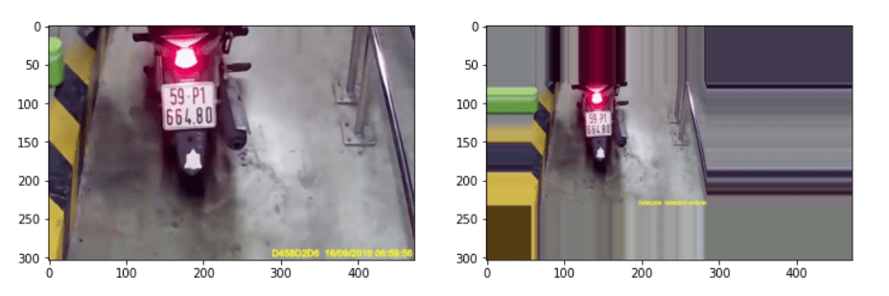

Figure 9. Diversify the data set by changing its size

* **low** and **high**: Are two positive integer values, determining the minimum (**low**) and maximum (**high**) border sizes that will be added to the image. These values are used to generate random values for the boundary.
* Then use the **random.randint** function to generate random values for the boundary size in directions (top, bottom, left, right) between **low** and **high**.
* Use the **cv2.copyMakeBorder** function to add borders to the image. This function will use the boundary size values created in the previous step and add them to the image.
* After adding borders, the image is larger in size than the original image. To keep the original size, we use the **cv2.resize** function to resize the image to its original size..

- Method 2: Crop the photo containing the license plate to a random size, then resize the photo to the original image size.

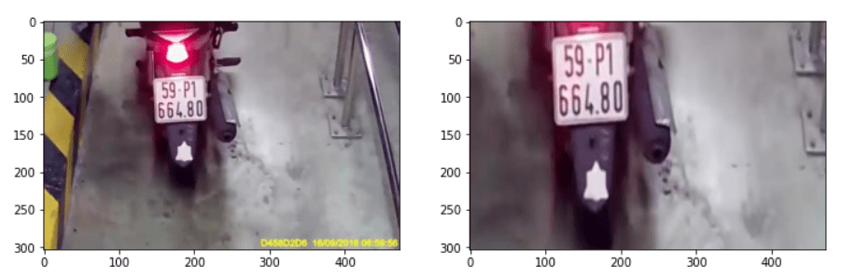

Figure 10. Resize license plate

* Get the original dimensions of the image (width and height) using **image.shape[1]** and **image.shape[0]**.
* Determine the image's center coordinates (x_center and y_center) by taking half of the original width and height.
* Generate random values for cutting coordinates using the **random.randint** function. In this case, we divide the image into four parts by cutting from the center and choosing a random part from them..
* Next, crop out the part of the image within the coordinates determined in the previous step, creating **cropped_image**.
* After cropping, the **cropped_image** image has a different size than the original image. To keep the original size, we use the **cv2.resize** function to resize the image to its original size..

***B, Change the brightness of the photo***

We change the brightness of the image by increasing or decreasing the value of the brightness channel (value) in the HSV color space of the image.

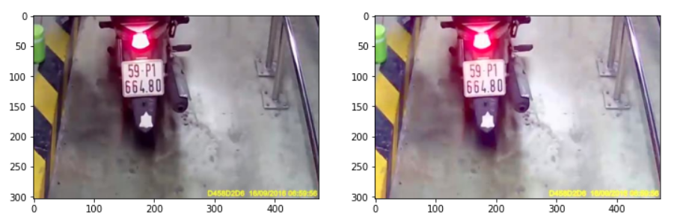

Figure 11. Increase/decrease the value of the luminance channel in the HSV color space

* Read the word image using **OpenCV** library and convert it to HSV color space using **cv2.cvtColor** function. HSV stands for **Hue** (color), **Saturation** (saturation), and **Value** (brightness).
* Then change the brightness of the brightness channel (Value). This change is done by adding value to channel v (brightness). This can increase or decrease the brightness of the photo.
* To ensure that the brightness value does not go above the limit 255 or below 0 (because the brightness value ranges from 0 to 255), use the statements v[v > 255] = 255 and v[v < 0] = 0 to limit the value of channel v.
* Once the brightness has been changed, use the **cv2.merge** function to re-merge the new Hue, Saturation, and luminance channels (results from the previous step) into a new HSV color image.
* Finally, convert the image from the HSV color space back to the BGR (RGB) color space using the **cv2.cvtColor** function.

***C, Rotate photo***

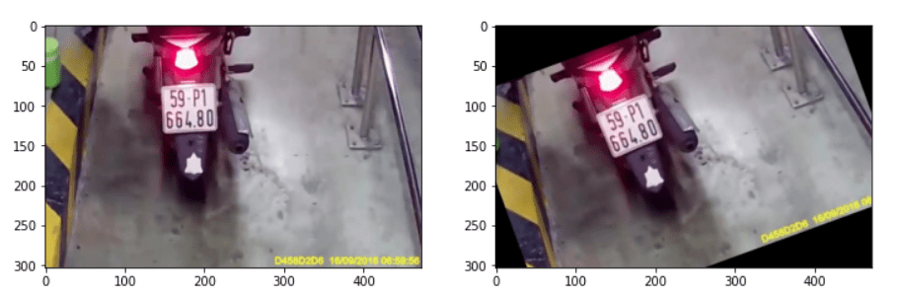

Figure 12. Rotate photos to random angles

* range_angle: Allowed rotation angle range. This is the range in which the random rotation angle will be selected. For example, if **range_angle** is 45, the rotation angle will be between -45 and 45 degrees.
* Use the **random.randint** function to select a random rotation angle between -range_angle and range_angle degrees. This generates a random value for the angle variable, representing the rotation angle of the image.
* Use **imutils** library to rotate images. The imutils.rotate function rotates the image according to the angle determined in the previous step (angle).
  1. **Proposed method for license plate recognition**
     1. ***Solution overview***



Figure 13. Solution overview

Figure 17 depicts an overview of the entire proposed license plate detection process. There are two main components in the system. The first component is a module that detects the license plate position in the frame. Next, based on the bounding box of each license plate, it will be cut and put into the character detection module. The output of all 2 models will be the license plate character string. When no license plate appears in the frame, the image is skipped and the processing flow continues to receive the next images. These models will be installed and executed on edge devices such as Raspberry Pi.

Inputs to the models included:

- Images of means of transport

- Continuous stream of frames from camera or video.

The output of the proposed model includes:

- Bouding box contains license plate number.

- Vehicle license plate character string detected.

The license plate detection module has a processing flow as shown in Figure 17, the input will be frames from the camera attached to the edge device, the output of the module is the license plate bounding box. The license plate detector used is a compact version of YOLOv8, this tiny version has a compact, lightweight structure, suitable for deployment on edge devices with low configuration.

The output image of the license plate detection module is processed to crop the area containing only the license plate, which is also the input image of the second module, character detection. Here, the Paddle-OCR model is used after the license plate image is preprocessed to bring it to 1 line. The processing flow of the second module is presented in Figure 18.

* + 1. ***License plate detection***

In the previous part of the topic, an overview of the problem's processing flow was presented. This part will go deeper into the techniques applied on the license plate detection module.

The license plate detection module takes as input a frame and detects the license plate contained in that frame. The figure above describes the processing flow of the license plate detection module. Before being fed into the model, the input image will be preprocessed to adjust the input image size to $416×416$ instead of the default size of $640×640$. This reduces computational pressure and reduces latency when models run on edge devices. After determining the bounding boxes, the results will be filtered to reduce the bounding boxes using the Non-Maximum Suppression (NMS) algorithm and retain the best results.

To perform the task of detecting license plates for many contexts, the project uses the YOLOv8n network on the PyTorch framework and on the edge device Raspberry Pi.

The output of the bounding box will include four points coordinates $x_{min}, y_{min},x_{max}, y_{max}$, of the object and the reliability of the prediction $confidence$.

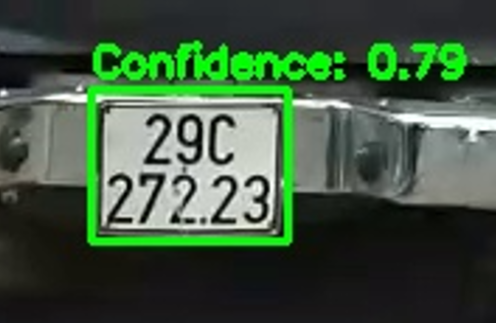

Figure 14 The YOLOv8 model detects license plates

Figure 19 shows the results when detecting license plates. In the condition that many license plates appear in one frame, the detector can still detect them. Besides, with lighting conditions changing between morning and evening, the detector still gives good recognition results.

The results of the license plate detection module are shown in the table below:

|  |  |  |  |  |
| --- | --- | --- | --- | --- |
| Model | Framework | Parameters | mAP50 | mAP50-95 |
| YOLOv8-tiny | PyTorch | 3.2M | 0.99394 | 0.74069 |

Table 1 The results of the license plate detection module

* + 1. ***License plate recognition***

After detecting and determining the position of the license plate in the image through the detection module, the next step is to extract and process the detected license plate so that the characters on the license plate can be read. This part includes two main steps: angle correction and image rotation, then license plate character detection.

1. ***Adjust image angle and rotation***

The goal of this step is to adjust the license plate so that the license plate's characters are on one line for easy inclusion in the character recognition model.

The technology used is OpenCV with the Canny algorithm for edge detection, helping to identify the border of the license plate. Then use geometric transformations to adjust the angle of the license plate, so that the license plate characters are placed horizontally on one line.

The process of adjusting image angle and rotation includes several main steps as follows:

- Apply Canny filter to detect the edge of the license plate.

- Use hough transform to find straight lines and thereby determine the tilt angle of the license plate.

- Apply geometric transformation to rotate and adjust the license plate to horizontal position.

- Separate the image into 2 parts, top and bottom, then combine them so that the license plate characters are on 1 line.

After drawing the straight lines, we have the following image:

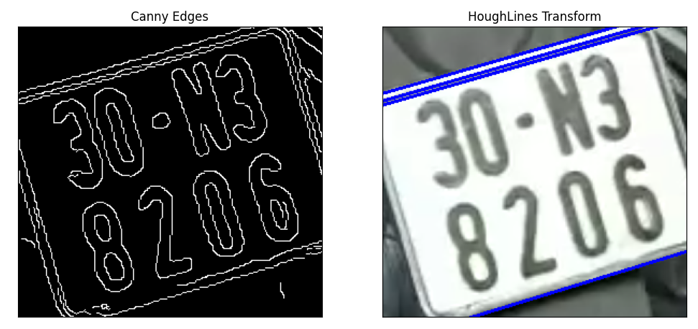

Figure 15. The straight lines are found by the algorithm

Now what you need to do is take out a straight line segment to compare with the photo frame to calculate the rotation angle. The goal is to make the license plate horizontal so that it is convenient to have a readable OCR model.

The proposed method is to take the longest line in the image, then calculate the angle created by that line and the border of the image, which is the angle that needs to be rotated. The following results:

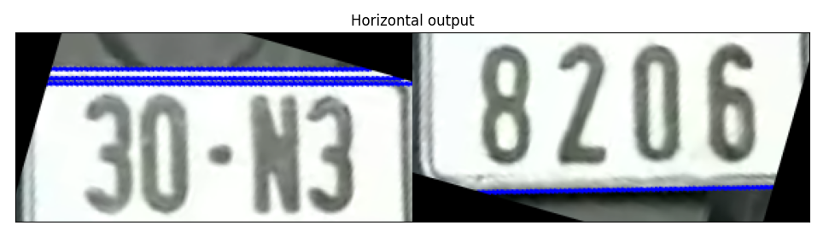

Figure 16. Take the longest line and rotate it according to the angle created by that line and the edge of the bounding box

***B. License plate characters recognition***

This part of the system is responsible for recognizing and extracting character information from calibrated license plates. The main goal is to achieve high accuracy in character recognition on license plate types, even in difficult conditions such as low light, dirty license plates or noisy images.

To achieve the above goal, the module will use PaddleOCR, a powerful and flexible OCR library. PaddleOCR is known for its multi-language support, including Vietnamese, helping to increase accuracy when identifying characters on license plates. PaddleOCR unites advanced image recognition technologies and is capable of adapting to character variations, especially in complex contexts.

The module uses the license plate image that has been calibrated from the license plate detection step as input. This image has been cropped and adjusted to include only the license plate area, with standardized size and format for character recognition. By applying PaddleOCR to detect and recognize characters on license plates. The model will scan through license plate images, using trained neural network models to accurately recognize and extract characters. The results obtained from PaddleOCR will be further processed to remove any misidentified characters, including removing invalid characters based on Vietnam's license plate regulations.



Figure 17 License plate characters recognition

Recognizing license plates from video is a challenge that requires precision and advanced techniques. During the recognition process, relying only on a single frame will not bring high accuracy because of many influencing factors such as the brightness of the environment or the obscuration of objects. These factors can make the license plate image blurry, difficult to read, or even invisible.

To increase the accuracy of license plate recognition, an effective method is to collect and analyze multiple frames from the video. Thereby, applying techniques such as regex (regular expressions) to filter out frames that match the standard format of Vietnamese license plates becomes important. Regular expressions allow the identification of characteristic character patterns, thereby helping to eliminate malformed frames, focusing on frames with a high probability of containing correct information.

After filtering out a set of satisfactory frames, the next step is to evaluate the accuracy of each frame. The final result will be based on the frame with the highest rating, thereby improving the accuracy in identifying license plates on video. By applying this method, license plate recognition is not just based on a random moment but is the result of a continuous analysis and evaluation process, helping to minimize the risk of errors and increase reliability for recognition system.

The results of license plate extraction are shown in the following table:

|  |  |  |  |
| --- | --- | --- | --- |
| Number of frames:  944  Number of plates:  944 | Detected:  696 plates | | Not detected: 248 plates |
| Number of license plates that OCR reads correctly | Number of license plates that OCR misreads |  |
| 540 | 156 |
| Accuracy: | 0.775 | |
| Character Error Rate - CER | 0.36 | |

Table 2 The results of license plate extraction

CER (character error rate) is the standard index to evaluate the effectiveness of Optical Character Recognition (OCR) models.

***C. Tracking license plate in the video***

After detecting an object in a frame, the next thing to do is to track the value of that object over time. Object detection only has the function of locating and classifying objects in a single frame. However, to identify objects that appear in two consecutive frames of the same object, we need an additional algorithm to track the object. In other words, the problem of object tracking is a higher level problem than object detection. The input object of the problem is not just an object that appears in a single frame but is a series of consecutive frames. In this problem, besides determining the object's location, we also need to pay attention to other factors such as:

* The identity of the object is represented by the ID, and this ID needs to remain constant throughout the object's appearance in a series of frames.
* The system needs to ensure that the correct ID of the object is recognized after it is obscured or disappears for a few frames.
* Need to ensure real-time processing speed.

Object tracking is the process of tracking an object's movements and preserving its identity, even if its appearance or movements change. Traditional methods for object tracking, such as Multiple Hypothesis Tracking (MHT) [81], generate multiple tracking paths for each object and use a data fusion algorithm to select the tracking path. most likely at each time step. However, developments in deep learning and object detection modeling with neural networks have led to the rapid development of modern tracking algorithms. These algorithms are a combination of object detection and motion modeling. The motion model uses the detection model's predicted bounding boxes at a given time interval as input to estimate the movements of objects and construct entities. For example, SORT [82] is a simple algorithm that uses a Kalman filter to predict the state of each object in each frame and a Hungarian algorithm to combine predicted states with detected objects. appears in the current frame to decide which object belongs to which object being tracked. And developed right from SORT can be referred to as Deep SORT, to solve the shortcomings related to a high number of ID switches. The solution proposed by deep SORT is based on the use of deep learning to extract object features to increase accuracy in the data association process. In addition, a linking strategy is also built called Matching Cascade to help link objects more effectively after they have disappeared for a while.

And with the problem of tracking many objects, for some applications that need high accuracy and the ability to handle complex situations, using DeepSort [83], can be considered a reasonable choice.

In multiple object tracking, especially for the tracking-by-detection algorithm class, there are two main factors that directly affect the tracking performance:

* Data Association: Concerned with the issue of data association, specifically the criteria for consideration and evaluation to associate a new detection with pre-stored tracks
* Track Life Cycle Management: Concerned with managing the life cycle of a stored track, including, when to initialize the track, when to stop tracking and delete the track from memory,...

In deep SORT, the authors solve the data association problem based on the Hungarian algorithm (similar to SORT), however, the association is not only based on IOU but also takes into account other factors: distance of detection and track (consider correlation in vector space) and cosine distance between 2 feature vectors extracted from detection and track (details are presented in the following sections) - 2 feature vectors of the same object will be similar.

In order to develop a feature extractor for each detection (bounding box) obtained, the algorithm has developed a Wide Residual Network architecture, trained specifically on large identifier datasets. people (large scale re-id dataset) such as: Market 1501, MARS,.... This task is also known as Cosine Metric Learing [84].

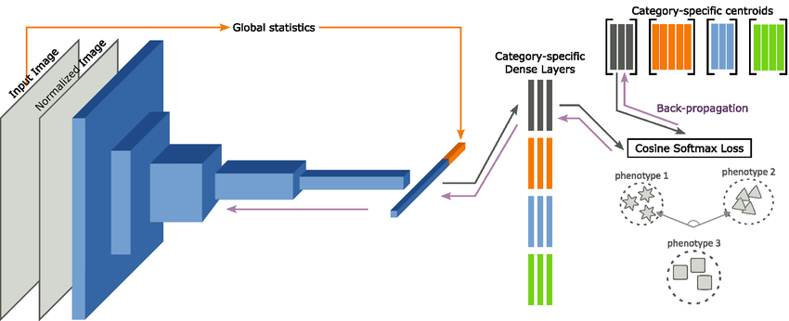

Figure 18. Deep Cosine Metric Learning model

The image is normalized, then fed into a Convolutional Neural Network. It then concatenates the global image statistics computed on the original image with the resulting feature vector and feeds it into a series of dense layers according to the phenotypic category recorded by its modality (red, green, blue and gray blocks). Finally, calculate the softmax cosine loss on each image of a batch and aggregate the gradients to update the centroids, category-specific dense layers, and the feature extraction backbone.

The 3 loss functions tested with this architecture are Sparse Softmax Cross Entropy Loss, Magnet Loss and Triplet Loss respectively; in which Cross Entropy Loss gives the most positive results.

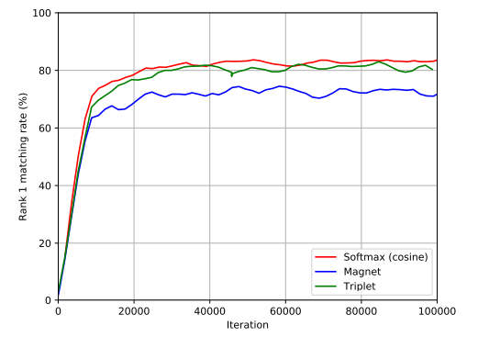

Figure 19. Evolution of validation set accuracy

* 1. **Optimal improvements**
     1. ***Modifying model architecture***

The main goal in this part of the project is to optimize the YOLOv8 model so that it can operate effectively on edge devices with limited computational resources. This optimization will focus on reducing the size of the model while maintaining acceptable accuracy. The optimization technique that will be applied is model pruning.

Pruning is the process of removing insignificant weights in the model, helping to reduce the size and complexity of the model. This method is based on the principle that not all neurons are needed to achieve high performance. There are several techniques for pruning models:

* Pruning weights: this method removes the smallest weights (values close to 0). This approach is often simple and effective, but is not always good because it can remove important weights in the model.
* Neuron pruning: this technique removes entire neurons, along with their incoming and outgoing connections. The remaining neurons are then retrained.
* Structured pruning: in this method, instead of removing weights one by one, structured pruning removes clusters of weights or channels within layers. This helps reduce network size more effectively without causing much performance loss.

In this topic, pruning will be conducted by identifying weights with values close to zero and removing them from the neural network. This is done based on analyzing the impact of each weight on the accuracy of the model. The model size after pruning will be compared with the original size to evaluate the degree of size reduction, as well as evaluate the accuracy to ensure that there is no significant loss. Below are the steps to perform weight pruning:

* Step 1: Determine the pruning threshold:

In this step, we need to determine a pruning threshold, usually a small percentage of the absolute value of the weight.

For example, if we choose the pruning threshold as $θ=0.1$, $w_{i}$ is the $i^{th}$ weight in the network, then all weights with absolute value $\left\|w_{i}\right\|<θ$ will be removed.

* Step 2: Remove unimportant weights:

Go through all the weights in the network and remove the weights whose absolute value is less than the pruning threshold determined in the previous step.

* Step 3: Fine-tuning (refine the model):

After removing unimportant weights, the model will often experience degraded performance. To restore performance, the model is often fine-tuned on the original training data set.

* + 1. ***Preprocessing input image***

The quality of the input image has a direct impact on the performance of the recognition model. This part of the project focuses on optimizing the image preprocessing process to improve the quality of input data, thereby improving the accuracy of the license plate recognition model.

The basic idea of Histogram Equalization is to flatten the histogram distribution of an image. Equalization implies mapping the distribution of the original histogram to another distribution (with wider and more uniform intensity values). Steps to calculate Histogram Equalization:

* Calculating Histogram: First, we calculate the image's histogram, which represents the distribution of light levels in the image. Histogram is a statistical graph of the number of pixels with the same brightness level.
* Calculating Cumulative Distribution Function (CDF): Next, we calculate the cumulative distribution function (CDF) of the histogram. CDF indicates the percentage of pixels whose brightness level is less than or equal to the brightness level of each intensity.
* Equalization: We then remap each original intensity value to a new value using CDF. This process creates a non-linear mapping from each pixel's original brightness level to the new brightness level, flattening the distribution of the histogram.
* Image remapping: Finally, we use the calculated mapping to update each pixel in the original image, thereby creating an equalized image.

Below is an example of an original license plate image in grayscale and after performing Histogram Equalization:

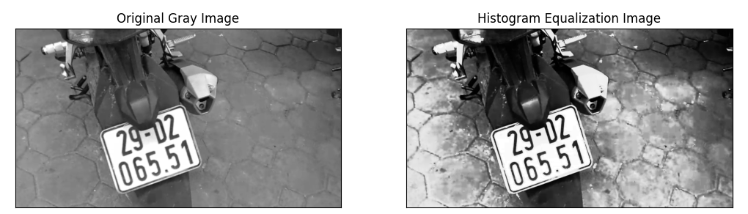

Figure 20. Gray-scale images are processed through the Histogram Equalization algorithm

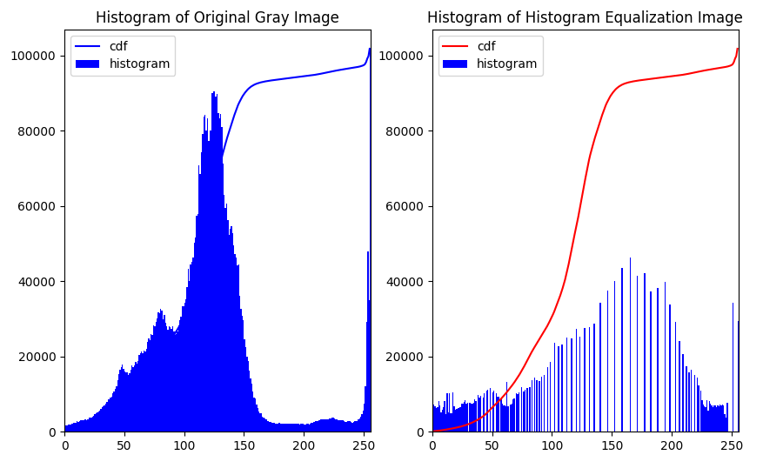

Figure 21. Intensity distribution of the image after Histogram Equalization processing

Noise always appears in digital images during the steps of acquisition, encoding, transmission and image processing... Noise reduction or noise filtering is a standard process used in almost every image processing system. Choosing the right filter depends on the type of data as well as the type of noise in the image. Some popular noise filters in image processing:

|  |  |
| --- | --- |
| Noise | Appropriate Filters |
| Salt & Pepper | Median filter |
| Poisson (or Shot noise, a type of noise that can be modeled using a Poisson process) | Mean filter |
| Gaussian noise (a common type of noise, appearing in many natural sources, following a normal distribution) | Mean/Gaussian/BilAtERAL filter |
| Speckle noise (often appears in medical images such as CT scans and X-rays) | Weiner |

Table 3 Some popular noise filters in image processing

With a set of license plate images, with the aim of optimizing the image processing process to produce the most optimal results, while limiting overly complicated methods that slow down the image processing process, here we only talk about popular methods include Mean filters, Gaussian Blur, and Median filters (methods of Order-statistic filters)::

* Gaussian Blur: The formula of the Gaussian Filter is represented by the Gauss function. The Gaussian function has smoothing and uniform properties, and is often used in image processing to blur images or reduce noise.
* Arithmetic Mean Filter: is the simplest case of Mean filter, this method calculates the average of the intensity values of pixels in a sliding window of size $m×n$. This filter smoothes local variations in the image and reduces noise caused by blurring.
* Geometric Mean Filter: This filter achieves smoothness comparable to the Arithmetic Mean Filter, but it tends to lose less image detail in the process.

In addition to the above two methods, Mean filter also has other methods such as Harmonic Mean Filter (works well for salt noise but not good for pepper noise) and Contraharmonic Mean Filter (suitable for reducing or virtually eliminates the effects of salt and pepper noise).

* Median filters: is the most common method of the Order-statistic filters. The basic idea of a Median Filter is to replace each pixel in an image with the median value of the pixels in a surrounding neighborhood.

Below is a noisy image processed through the above methods:

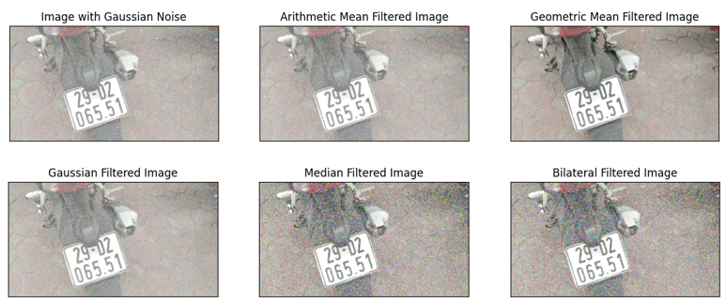

Figure 22. Images are processed through filters

Multi-threaded processing: Apply multi-threading to parallelize image pre-processing and model inference, minimizing waiting time and optimizing overall processing speed.

Results after applying the Histogram Equalization method:

|  |  |  |  |
| --- | --- | --- | --- |
| Number of frames:  944 | Detected:  721 plates | | Not detected: 273 plates |
| Number of license plates that OCR reads correctly | Number of license plates that OCR misreads |  |
| 554 | 167 |
| Accuracy: | 0.768 | |
| Character Error Rate - CER | 0.25 | |

Table 4 Results after applying the Histogram Equalization method

It can be seen that after applying Histogram Equalization, the number of detected license plates compared to Table 2 increased (from 696 plates to 721 plates), the correct reading rate (accuracy) of the OCR model decreased slightly, however the signing error rate (CER) has been significantly reduced (from 0.36 to 0.25). This may be effective because the contrast of the image is enhanced.

Results after applying the Gaussian Blur:

|  |  |  |  |
| --- | --- | --- | --- |
| Number of frames:  944 | Detected:  655 plates | | Not detected: 339 plates |
| Number of license plates that OCR reads correctly | Number of license plates that OCR misreads |  |
| 550 | 105 |
| Accuracy: | 0.83 | |
| Character Error Rate - CER | 0.34 | |

Table 5 Results after applying the Gaussian Blur

Although the accuracy of the OCR model increased compared to the original, the number of detected license plates compared to Table 2 has decreased (from 696 to 655 plates), along with the character error rate (CER). significantly reduced. It can be seen that the method of smoothing images with Gaussian Blur is not really effective, this may be because the image does not really have many noisy pixels and the image is blurred.

# **Chapter 4: Evaluating method on edge device**

## 4.1. Implementing the method on edge device

### ***4.1.1. Introduction to Edge Device***

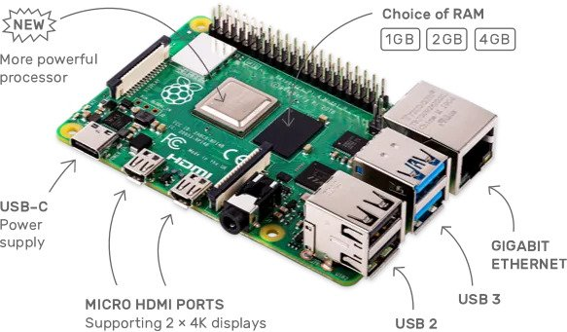

Figure 23 Raspberry Pi 4

Raspberry Pi is an iPhone-sized computer that runs the Linux operating system. The main goal of the program is to teach computers to children. Developed by the Raspberry Pi Foundation - a non-profit organization with the goal of building a system that many people can use in various customization jobs. Raspberry Pi is manufactured by 3 OEMs: Sony, Qsida, Egoman, and is mainly distributed by Element14, RS Components and Egoman.

The initial mission of the Raspberry Pi project was to create an inexpensive, programmable computer for students, but the Pi has attracted interest from many different audiences. Raspberry Pi's features are built around the Broadcom BCM2835 SoC processor (a powerful mobile processor with a small size often used in mobile phones) including CPU, GPU, audio/video processor, and other features... all built into this low-power chip.

The Raspberry Pi is a surprisingly versatile device with lots of low-cost hardware that's perfect for electronic systems, DIY projects, and inexpensive computing setups for hands-on programming lessons. submit.

In this project, we use the Raspberry Pi 4 Model B 2019 version with the following configuration:

* Broadcom BCM2711, Quad core Cortex-A72 (ARM v8) 64-bit SoC @ 1.5GHz
* 8GB LPDDR4-2400 SDRAM
* Wifi standard 2.4 GHz and 5.0 GHz IEEE 802.11ac. Bluetooth 5.0, BLE
* Power source DC 5V – 3A DC standard USB-C

### ***4.1.2. System architecture overview***

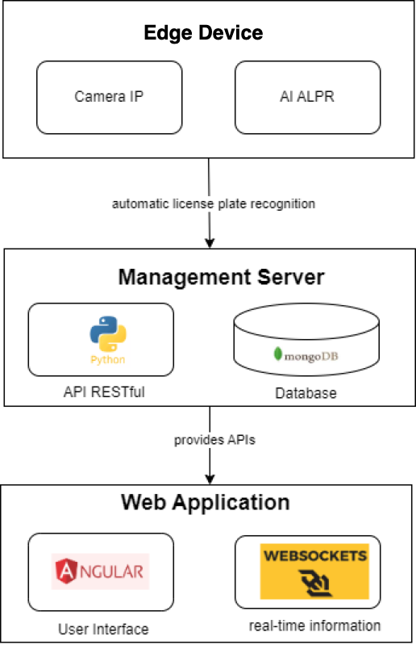

Figure 24 System architecture overview

The vehicle control system at the parking lot includes the following main components:

* Edge device play an important role in the vehicle control system at the parking lot, with the main purpose of automatically identifying vehicles when they enter or leave the parking lot. To perform this task, the system uses IP cameras combined with the license plate recognition method proposed in the project. This device is directly connected to the server via LAN or WAN, allowing it to quickly send vehicle image data and recognized license plates to the server. In addition, to enhance the ability to control the entry and exit of vehicles, the system can also be integrated with sensors and automatic barriers, ensuring a smooth and safe operating process at the parking lot.
* The Management Server plays a central role in the main task of managing the database, handling complex business logic, and providing necessary APIs for other components of the system. To achieve this goal, I recommend using Python and the Flask library to build RESTful APIs. The system selects the MongoDB database for a non-relational data structure. This server will handle all requests coming from the identity edge device and web software, including managing user information, vehicles and transaction history. In addition, the server also takes care of calculating parking fees, managing parking locations in the lot and sending notifications to users.
* Web Application creates an intuitive and easy-to-use interface for both parking lot managers and parking lots, helping them easily access relevant information, manage vehicles, and monitor parking lot status effectively. To build this user interface, I chose Angular as the main technology because of its powerful and flexible capabilities in developing single-page application websites. At the same time, the use of WebSocket allows for real-time information updates, providing a smooth and seamless user experience. Managers can easily view reports, manage vehicles and consignors, as well as install and fine-tune system settings through the management interface. Meanwhile, vehicle consignors are provided with functions to check the status of their vehicle, make payments, and view parking history, helping to increase convenience and transparency in the process of using the service. parking lot.

### ***4.2.2. Vehicle control flow diagram at the parking lot***

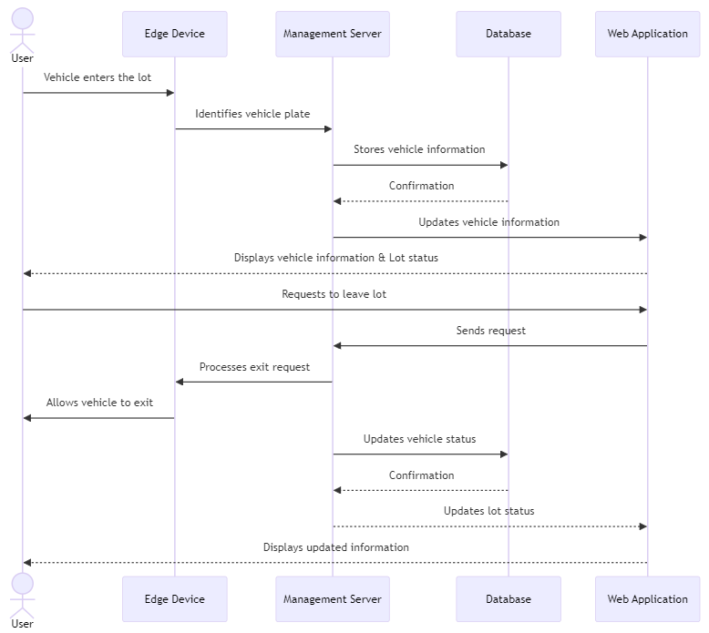

Figure 25 Vehicle control flow diagram at the parking lot

In this diagram:

* User drives the vehicle into the parking lot.
* Edge Device uses an IP camera and AI technology to identify the vehicle's license plate and notifies the Management Server.
* Management Server records the vehicle's information in the Database and updates the vehicle's status in the lot.
* Web Application receives information from the Management Server and displays the vehicle's information and the status of the parking lot to the User.
* When the User wishes to leave the lot, they make a request through the Web Application.
* Management Server receives the request and instructs the Edge Device to process the vehicle's exit.
* Edge Device allows the vehicle to exit and updates the Management Server on the status.
* Management Server updates the information in the Database and notifies the Web Application of the new lot status, which then displays the updated information to the User.

## 4.3. Performance evaluation on edge device

### ***4.3.1 Processing Performance***

Processing speed is calculated by the number of frames processed per second. Results are also reported for different input sizes from 1000 pre-recorded frames.

|  |  |
| --- | --- |
| Input size | FPS |
| 240 | 24.5 |
| 480 | 12.6 |
| 640 | 7.9 |

*Table 6 Processing speed evaluation table of the method used on Raspberry Pi 4*

### ***4.3.2 Accuracy***

The accuracy of the implementation on the Raspberry Pi 4 edge device is evaluated by calculating the number of correctly recognized license plates out of a total of 36 license plates in the test video set.

|  |  |  |  |
| --- | --- | --- | --- |
| Input size | Detection | Total | Percision |
| 240 | 9 | 36 | 0.25 |
| 480 | 17 | 0.47 |
| 640 | 28 | 0.77 |

Table 7 Table to evaluate the accuracy of the method used on Raspberry Pi 4

Experimental results show that by using a smaller input size, a higher processing speed can be achieved. Of course, there is a trade-off with the decrease in accuracy in object prediction. The smaller the input size, the higher the processing speed, which means the accuracy will decrease because the model will have to work with a smaller amount of information, leading to reduced accuracy in object detection. As objects in an image become smaller due to size reduction, they may become more difficult to recognize, especially for small or distant objects, so part of the information about the objects may be lost. lost. This can make objects less recognizable or even impossible to identify.

To improve the accuracy of license plate recognition, an effective solution is to apply data augmentation techniques and use deep learning models that can extract good features from the dimensions. small input. Data augmentation makes the model more robust to variation in real-world data by introducing variations such as rotation, zoom in/out, and distortion, thereby helping the model learn important features from small-sized images. In addition, combining image segmentation and preprocessing methods such as contrast enhancement and image smoothing can help improve model recognition by making license plate features more visible. more clearly.

# **CHAPTER 5: CONCLUSION**

## 5.1. Summary

This research focuses on automatic license plate recognition (ALPR) on edge devices, an important problem with wide practical applications. License plate recognition methods have been surveyed, evaluated and optimized to meet performance and accuracy requirements on edge devices. Using edge computing systems has been highlighted as a solution to improve the performance and reliability of license plate recognition systems. This not only helps reduce latency and increase processing speed but also reduces network bandwidth and data storage costs.

The project has also added a dataset that reflects a variety of real-life conditions encountered in recognizing license plates in practice. Along with that, the project proposes a new system architecture optimized for effective deployment in parking lot environments. This new system architecture not only leverages the power of edge computing but is also designed to easily integrate with existing parking management systems, providing a flexible and powerful total solution for Identifying and managing vehicle entry and exit.

## 5.2. Future Work

Further research and development directions will focus on further exploring and optimizing license plate recognition methods, including research into new deep neural network models and complex network architectures. more complex and consider deploying them on edge devices more efficiently.

In addition, it is also important to research how to reduce model size and increase inference speed without losing accuracy. Improving processing performance on edge devices will open up many new practical applications, such as automatic traffic monitoring, smart parking lots and automatic toll stations. This requires close integration between software and hardware, as well as consideration of edge computing solutions to process data at the source effectively.

# **REFERENCES**

|  |  |
| --- | --- |
| [1] | H. B. a. C. Liu, "A hybrid license plate extraction method based on edge statistics and morphology," *Int. Conf. Patt. Recog,* vol. vol. 2, pp. pp. 831-834, 2004. |
| [2] | D. Z. e. al, "An efficient method of license plate location," *Pattern recog. Letter,* vol. 26, no. 15, pp. 2431-2438, 2005. |
| [3] | S. W. a. H. Lee, "Detection and recognition of license plate characters with different appearances," *Int. Conf. Intell. Transp. Syst.,* vol. vol. 2, pp. pp. 979- 984, 2003. |
| [4] | F. F. e. al, "A morphological-based license plate location," *IEEE Int. Conf. Image Process,* vol. 1, pp. 57-60, 2007. |
| [5] | Z. Q. e. al, "Method of license plate location based on corner feature," *in Proc. World Congr. Intell. Control Automat,* vol. 2, pp. 8645-8649. |
| [6] | J. M. e. al, "Unconstrained license plate and text loc recognition," *IEEE Int. Conf. intell. Transp. Syst,* pp. 225-230. |
| [7] | B.-F. W. e. al, "Extracting characters from real vehicle license plates out-ofdoors," *IET Comput. Vision,* vol. 1, no. 1, pp. 2-10, 2007. |
| [8] | M. M. I. C. a. S. A. Zimmerman, "License plate locatio dynamic PCNN scheme," *Int. Joint Conf. Neur. Netw,* vol. 2, 2003. |
| [9] | F. Y. a. Z. Ma, "Vehicle license plate location based on h and mathematical morphology," *IEEE Workshop Automa. Ident Techn,* pp. 89-94, 2005. |
| [10] | R. Z. a. S. Rovetta, "Vector quantization for license-plat image coding," *IEEE Trans. Ind. Electron,* vol. 47, no. 1, pp. 159-167, 2000. |
| [11] | C.-N. E. A. e. al, "A license plate-recognition intelligent transportation system applications," *IEEE Trans. Syst.,* vol. 7, no. 3, pp. 377-392, 2006. |
| [12] | H.-U. C. a. K.-H. J. K. Deb, "Vehicle license plate dete based on sliding concentric windows and histogram," *J. of Co ,* no. 8, pp. 771-777, 2009. |
| [13] | C.-T. H. e. al, "Multiple license plate detection for complex background," *Int. Conf. Adv. Inform. Netw. and Applicat.,* vol. 2, pp. 389-395, 2005. |
| [14] | L. Dlagnekov, "License Plate Detection Using AdaBoost," *Com and Engineering Department, San Diego,* 2004. |
| [15] | X. S. e. al, "Automatic License Plate Recognition System Based on Color Image Processing," vol. 3483, O. G. e. al, Ed., SpringerVerlag, 2005, pp. 1159-1168. |
| [16] | S.-L. C. e. al, "Automatic license plate recognition," *IEEE Trans. Intell. Transp. Syst.,* vol. 5, no. 1, pp. 42-53, 2004. |
| [17] | S. Y. e. al, "License plate detection system by using threshold function and improved template matching method," *IEEE Annu. Meet. of the Fuzzy Inform.,* vol. 1, pp. 357-362, 2004. |
| [18] | W. J. e. al, "Gaussian weighted histogram intersection for license plate classification," *Int. Conf. Patt. Recog.,* vol. 3, pp. 574-577, 2006. |
| [19] | X. W. e. al, "A vehicle license plate localization method using color barycenters hexagon model," *Proc. of SPIE,* vol. 8009, pp. 80092O-1- 80092O-5, 2011. |
| [20] | K. D. a. K.-H. Jo, "A Vehicle license plate detection method for intelligent transportation system applications," *Cybern. and Syst.: An Int. J.,* vol. 40, pp. 689-705, 2009. |
| [21] | J. M. a. K. Zimmermann, "Unconstrained license plate and text localization and recognition," *EEE Conf. Intell. Transp. Syst.,* pp. 572-577, 2005. |
| [22] | S. Draghici, "A neural network based artificial vision system for license plate recognition," *Int. J. on Neural Syst.,* vol. 8, no. 1, pp. 113-126, 1997. |
| [23] | F. A. a. P. S. Girao, "Vehicle plate recognition for wireless traffic control and law enforcement system," *IEEE Int. Conf. Ind. Tech.,* pp. 1800-1804, 2006. |
| [24] | H. W. L. a. Y. H. Tay, "Detection of license plate characters in natural scene with MSER and SIFT unigram classifier," *IEEE Conf. Sustainable Utilization and Development in Eng. and Tech.,* pp. 95-98, 2010. |
| [25] | Z. Selmi, M. B. Halima, and A. M. Alimi, ‘‘Deep learning system for automatic license plate detection and recognition,’’ in Proc. 14th IAPR Int. Conf. Document Anal. Recognit. (ICDAR), Nov. 2017, pp. 1132–1138. |
| [26] | L. Zou, M. Zhao, Z. Gao, M. Cao, H. Jia, and M. Pei, ‘‘License plate detection with shallow and deep CNNs in complex environments,’’ Complexity, vol. 2018, pp. 1–6, Dec. 2018. |
| [27] | J. Redmon, S. Divvala, R. Girshick, and A. Farhadi, ‘‘You only look once: Unified, real-time object detection,’’ in Proc. IEEE Conf. Comput. Vis. Pattern Recognit. (CVPR), Jun. 2016, pp. 779–788. |
| [28] | G.-S. Hsu, A. Ambikapathi, S.-L. Chung, and C.-P. Su, ‘‘Robust license plate detection in the wild,’’ in Proc. 14th IEEE Int. Conf. Adv. Video Signal Based Surveill. (AVSS), Aug. 2017, pp. 1–6. |
| [29] | L. Xie, T. Ahmad, L. Jin, Y. Liu, and S. Zhang, ‘‘A new CNN-based method for multi-directional car license plate detection,’’ IEEE Trans. Intell. Transp. Syst., vol. 19, no. 2, pp. 507–517, Feb. 2018. |
| [30] | W. W. L. W. S. C. X. H. J. L. J. T. a. J. Y. X. Li, "Generalized focal loss: Learning qualified and distributed bounding boxes for dense object detection," *Advances in Neural Information Processing Systems,* vol. 33, p. 21002–21012, 2020. |
| [31] | X. X. e. al, "A method of multi-view vehicle license plates location based on rectangle features," *Int. Conf. Signal Process.,* vol. 3, pp. 16-20, 2006. |
| [32] | M.-S. P. e. al, "Vehicle license plate character segmentation," *Int. J. Automat. and Comput.,* vol. 5, no. 4, pp. 425-432, 2008. |
| [33] | M.-S. P. e. al, "A new method for correcting vehicle license plate tilt," *Int. J. of Automat. and Comput.,* vol. 6, no. 2, pp. 210-216, 2009. |
| [34] | K. D. e. al, "Projection and least square fitting with perpendicular offsets based vehicle license plate tilt correction," *SICE Annu. Conf.,* pp. 3291-3298, 2010. |
| [35] | P. C. e. al, "Optical recognition of motor vehicle license plates," *IEEE Trans. Veh. Tech.,* vol. 44, no. 4, pp. 790-799, 1995. |
| [36] | a. C. Z. Y. Zhang, "A new algorithm for character segmentation of license plate," *IEEE Intell. Veh. Symp.,* pp. 106-109, 2003. |
| [37] | D. L. e. al, "Car License Plates Extraction and Recognition Based on Connected Components Analysis and HMM Decoding," vol. 3522, J. S. M. e. al, Ed., New York, Springer-Verlag, 2005, pp. 571-578. |
| [38] | C. C. e. al, "PC based number plate recognition system," *IEEE Int. Symp. Ind. Electron.,* pp. 605-610, 1998. |
| [39] | V. S. a. G. Gluhchev, "Multinational license plate recognition system: segmentation and classification," *Proc. of Int. Conf. on Patt. Recog.,* vol. 4, pp. 352-355, 2004. |
| [40] | S. Z. e. al, "Car plate character extraction under complicated environment," *IEEE Int. Conf. Syst. Man Cybern.,* vol. 5, pp. 4722-4726, 2004. |
| [41] | E. R. L. e. al, "Automatic recognition of a car license plate using color image processing," *IEEE Int. Conf. Image Process.,* vol. 2, pp. 301-305, 1994. |
| [42] | C. A. R. e. al, "A real time vehicle’s license plate recognition system," *IEEE Conf. Adv. Video and Signal Based Surveillance,* pp. 163-166, 2003. |
| [43] | C. B. e. al, "Feature based recognition of traffic video streams for online route tracing," *IEEE Veh. Tech. Conf.,* vol. 3, pp. 1790-1794, 1998. |
| [44] | e. a. I. Paliy, "Approach to recognition of license plate numbers using neural networks," *IEEE Int. Joint Conf. Neur. Netw.,* vol. 4, pp. 2965-2970, 2004. |
| [45] | Q. G. e. al, "License plate recognition based on prior knowledge," *IEEE Int. Conf. Automat. and Logistics,* pp. 2964-2968, 2007. |
| [46] | J.-M. G. a. Y.-F. Liu, "License plate localization and character segmentation with feedback self-learning and hybrid binarization techniques," *IEEE Trans. Veh. Tech.,* vol. 57, no. 3, pp. 1417-1424, 2008. |
| [47] | A. C. a. M. Gokmen, "Concurrent segmentation and recognition with shape-driven fast marching methods," *Int. Conf. Patt. Recog.,* vol. 1, pp. 155- 158, 2006. |
| [48] | J. A. Sethian, "A fast marching level set method for monotonically advancing fronts," *National Academy of Sci.,* vol. 93, pp. 1591-1595, 1996. |
| [49] | P. S. a. M. Domanski, "Efficient unassisted video segmentation using enhanced fast marching," *Int. Conf. Image Process,* vol. 2, pp. 427-430, 2003. |
| [50] | M. S. e. al, "Saudi Arabian license plate recognition system," *Int. Conf. Geom. Model. and Graphics.,* pp. 36-41, 2003. |
| [51] | K. K. e. al, "Development of vehicle-license number recognition system using real-time image processing and its application to travel-time measurement," *IEEE Veh. Tech. Conf.,* pp. 798-804, IEEE Veh. Tech. Conf.. |
| [52] | S. T. a. W. Li, "Number and letter character recognition of vehicle license plate based on edge Hausdorff distance," *Inter. Conf. Parallel and Distributed Comput., Applicat., and Tech.,* pp. 850-852, 2005. |
| [53] | X. L. e. al, "Vehicle license plate character recognition," *Int. Conf. Neur. Netw. and Signal Process.,* vol. 2, pp. 1066-1069, 2003. |
| [54] | T. N. e. al, "Robust license-plate recognition method for passing vehicles under outside environment," *IEEE Trans. Veh. Tech.,* vol. 49, no. 6, pp. 2309-2319, 2000. |
| [55] | Y. D. e. al, "Automatic recognition of province name on the license plate of moving vehicle," *nt. Conf. Patt. Recog,* vol. 2, pp. 927-929, 1988. |
| [56] | H. A. H. e. al, "A high performance license plate recognition system," *IEEE Int. Conf. Syst. Man Cybern.,* vol. 5, pp. 4357-4362, 1998. |
| [57] | F. A. a. H. Ndungo, "Automatic license plate recognition system," *AFRICON Conf. in Africa,* vol. 1, pp. 45-50, 2004. |
| [58] | M. F. a. M. K. T. Nukano, "Vehicle license plate character recognition by neural networks," *Proc. of Int. Symp. on Intell. Signal Process. and Commun. Syst.,* pp. 771-775, 2004. |
| [59] | M.-A. K. a. Y.-M. Kim, "A simple OCR method from strong perspective view," *Applied Imagery Pattern Recognition Workshop,* pp. 235-240, 2004. |
| [60] | M.-K. K. a. Y.-B. Kwon, "Multi-font and multi-size character recognition based on the sampling and quantization of an unwrapped contour," *Int. Conf. Patt. Recog.,* vol. 3, pp. 170-174, 1996. |
| [61] | P. H. e. al, "Recognition of gray character using Gabor filters," *Int. Conf. Inform. Fusion,* vol. 1, pp. 419-424, 2002. |
| [62] | .. N. H. S. A. e. al, "License plate recognition using multi-cluster and multilayer neural networks," *Inform. and Commun. Tech.,* vol. 1, pp. 1818- 1823, 2006. |
| [63] | P. D. a. A. Thammano, "Thai vehicle license plate recognition using the hierarchical cross-correlation ARTMAP," *IEEE Int. Conf. Intell. Syst.,* pp. 652-655, 2006. |
| [64] | J. J. e. al, "A configurable method for multi-style license plate recognition," *Pattern Recog.,* vol. 42, pp. 358-369, 2009. |
| [65] | Y. A. e. al, "A coarse-to-fine strategy for multiclass shape detection," *IEEE Trans. Pattern Anal. Mach. Intell.,* vol. 26, no. 12, pp. 1606-1621, 2004. |
| [66] | Y. Amit, "A neural network architecture for visual selection," *Neural Comput.,* vol. 12, no. 5, pp. 1059-1082, 2020. |
| [67] | Y. A. a. D. Geman, "A computational model for visual selection," *Neural Comput,* vol. 11, no. 7, pp. 1691-1715, 1999. |
| [68] | S. Wang and H. Lee, " A cascade framework for a real-time statistical plate recognition system," *IEEE Trans. Inf. Forensics Secur,* vol. 2, p. 267–282, 2007. |
| [69] | K. K. K. e. al, "Learning-based approach for license plate recognition," *IEEE Signal Process. Soc. Workshop Neur. Netw. for Signal Process.,* vol. 2, pp. 614-623, 2000. |
| [70] | P. Z. a. L. H. Chen, "A novel feature extraction method and hybrid tree classification for handwritten numeral recognition," *Pattern Recog. Letter,* vol. 23, no. 1, pp. 45-56, 2002. |
| [71] | H. E. K. a. K. K. Cevik, "Artificial neural networks based vehicle license plate recognition," *Proce. Comput. Sci.,* vol. 3, pp. 1033-1037, 2011. |
| [72] | C. J. A. a. M. Shridhar, "Recognition of handwritten numerals with multiple feature and multistage classifier," *Pattern Recog.,* vol. 2, no. 28, pp. 153-160, 1995. |
| [73] | Y. S. H. a. C. Y. Suen, "A method of combining multiple experts for the recognition of unconstrained handwritten numerals," *IEEE Trans. Pattern Anal. Mach. Intell.,* vol. 17, no. 1, pp. 90-93, 1995. |
| [74] | Y. D. e. al., "PP-OCR: A Practical Ultra Lightweight OCR System," *arXiv:2009.09941 [cs.CV], Sep.,* 2020. |
| [75] | Y. D. e. al, "PP-OCRv2: Bag of Tricks for Ultra Lightweight OCR System," *arXiv:2109.03144 [cs.CV], Sep.,* 2021. |
| [76] | C. L. e. al., "PP-OCRv3: More Attempts for the Improvement of Ultra Lightweight OCR System," *arXiv:2206.03001 [cs.CV], Jun.,* Jun. 2022. |
| [77] | W. Y. A. M. N. L. H. H. C. Y. a. L. H. Z. Xu, "Towards end-to-end license plate detection and recognition: A large dataset and baseline," *European Conference on Computer Vision,* p. 261–277, 261–277. |
| [78] | E. S. L. A. Z. L. S. O. G. R. G. W. R. S. a. D. M. R. Laroca, "A robust real-time automatic license plate recognition based on the yolo detector," *A robust real-time automatic license plate recognition based on the yolo detector,* p. 1–10, July 2018. |
| [79] | J.-C. C. a. Y.-Z. C. G.-S. Hsu, "Application-oriented license plate recognition," *IEEE transactions on vehicular technology,* vol. 62, no. 2, p. 552–561, 2013. |
| [80] | W. Z. Y. Z. X. W. X. H. a. N. K. Y. Yuan, "A robust and efficient approach to license plate detection," *IEEE Transactions on Image Processing,* vol. 26, no. 3, p. 1102–1114, 2017. |
| [81] | D. Reid, "An algorithm for tracking multiple targets," *IEEE transactions on Automatic Control, jourvol 24, number 6,* p. 843–854, 1979. |
| [82] | Z. G. L. O. F. R. a. B. U. A. Bewley, "Simple online and realtime tracking," *IEEE international conference on image processing (ICIP) IEEE,* p. 3464–3468, 2016. |
| [83] | A. B. D. P. Nicolai Wojke, "Deep SORT - Simple Online and Realtime Tracking with a Deep Association Metric," *IEEE International Conference on Image Processing (ICIP),* pp. 2381-8549, 2017. |
| [84] | A. B. Nicolai Wojke, "Deep Cosine Metric Learning for Person Re-Identification (2018)," *2018 IEEE Winter Conference on Applications of Computer Vision (WACV),* pp. 748-756, 2018. |

# **APPENDIX 01**

Thông tư 24/2023/TT-BCA quy định về cấp, thu hồi Đăng ký, biển số xe cơ giới

**Biển số xe ô tô:**

Xe ô tô được gắn 02 biển số, 01 biển số kích thước ngắn: Chiều cao 165 mm, chiều dài 330 mm; 01 biển số kích thước dài: Chiều cao 110 mm, chiều dài 520 mm.

a) Cách bố trí chữ và số trên biển số ô tô của cơ quan, tổ chức, cá nhân trong nước: Hai số đầu là ký hiệu địa phương đăng ký xe, tiếp theo là sêri đăng ký (chữ cái); nhóm số thứ hai là thứ tự xe đăng ký gồm 05 chữ số tự nhiên từ 000.01 đến 999.99;

b) Cách bố trí chữ và số trên biển số xe ô tô của cơ quan, tổ chức, cá nhân nước ngoài: Hai số đầu là ký hiệu địa phương đăng ký xe, tiếp theo nhóm thứ hai là ký hiệu tên nước, vùng lãnh thổ, tổ chức quốc tế gồm 03 số tự nhiên và nhóm thứ ba là sêri biển số chỉ nhóm đối tượng là tổ chức, cá nhân nước ngoài, nhóm thứ tư là thứ tự xe đăng ký gồm 02 số tự nhiên từ 01 đến 99;

c) Biển số của máy kéo, rơmoóc, sơmi rơmoóc gồm 1 biển gắn phía sau xe, kích thước: Chiều cao 165 mm, chiều dài 330 mm; cách bố trí chữ và số trên biển số như biển số xe ô tô trong nước.

**Biển số xe máy:**

Xe mô tô được cấp biển số gắn phía sau xe, kích thước: Chiều cao 140 mm, chiều dài 190 mm.

a) Cách bố trí chữ và số trên biển số mô tô của cơ quan, tổ chức, cá nhân trong nước: Nhóm số thứ nhất là ký hiệu địa phương đăng ký xe và sêri đăng ký. Nhóm số thứ hai là thứ tự xe đăng ký gồm 05 chữ số tự nhiên, từ 000.01 đến 999.99;

b) Cách bố trí chữ và số trên biển số xe mô tô của tổ chức, cá nhân nước ngoài: Nhóm thứ nhất là ký hiệu địa phương đăng ký xe, nhóm thứ hai là ký hiệu tên nước, vùng lãnh thổ, tổ chức quốc tế của chủ xe, nhóm thứ ba là sêri đăng ký và nhóm thứ tư là thứ tự xe đăng ký gồm 03 chữ số tự nhiên từ 001 đến 999.

**Màu sắc, sêri biển số xe:**

5. Màu sắc, sêri biển số xe của cơ quan, tổ chức, cá nhân trong nước:

a) Biển số xe ô tô nền màu xanh, chữ và số màu trắng, sêri biển số sử dụng lần lượt một trong 11 chữ cái sau đây: A, B, C, D, E, F, G, H, K, L, M cấp cho xe của các cơ quan của Đảng; Văn phòng Chủ tịch nước; Văn phòng Quốc hội và các cơ quan của Quốc hội; Văn phòng Đoàn đại biểu Quốc hội, Hội đồng nhân dân các cấp; các Ban chỉ đạo Trung ương; Công an nhân dân, Tòa án nhân dân, Viện kiểm sát nhân dân; các bộ, cơ quan ngang bộ, cơ quan thuộc Chính phủ; Ủy ban an toàn giao thông quốc gia; Ủy ban nhân dân các cấp và các cơ quan chuyên môn thuộc Ủy ban nhân dân cấp tỉnh, cấp huyện; tổ chức chính trị - xã hội (gồm Mặt trận Tổ quốc Việt Nam, Công đoàn Việt Nam, Đoàn Thanh niên Cộng sản Hồ Chí Minh, Hội liên hiệp Phụ nữ Việt Nam, Hội Cựu chiến binh Việt Nam, Hội Nông dân Việt Nam); đơn vị sự nghiệp công lập, trừ Trung tâm đào tạo sát hạch lái xe công lập; Ban quản lý dự án có chức năng quản lý nhà nước;

b) Biển số xe mô tô nền màu xanh, chữ và số màu trắng, sêri biển số sử dụng lần lượt một trong 11 chữ cái sau đây: A, B, C, D, E, F, G, H, K, L, M kết hợp với 1 chữ số tự nhiên từ 1 đến 9, cấp cho xe của các đối tượng quy định tại điểm a khoản này;

c) Biển số xe ô tô nền màu trắng, chữ và số màu đen, sêri biển số sử dụng lần lượt một trong 20 chữ cái sau đây: A, B, C, D, E, F, G, H, K, L, M, N, P, S, T, U, V, X, Y, Z cấp cho xe của các tổ chức, cá nhân trong nước, không thuộc đối tượng quy định tại điểm a khoản này;

d) Biển số xe mô tô nền màu trắng, chữ và số màu đen, sêri biển số sử dụng lần lượt một trong 20 chữ cái sau đây: A, B, C, D, E, F, G, H, K, L, M, N, P, S, T, U, V, X, Y, Z kết hợp với một trong 20 chữ cái A, B, C, D, E, F, G, H, K, L, M, N, P, S, T, U, V, X, Y, Z cấp cho xe của các tổ chức, cá nhân trong nước, không thuộc đối tượng quy định tại điểm a khoản này; đ) Biển số xe ô tô nền màu vàng, chữ và số màu đen cấp cho xe hoạt động kinh doanh vận tải bằng ô tô, sử dụng lần lượt một trong 20 chữ cái sau đây: A, B, C, D, E, F, G, H, K, L, M, N, P, S, T, U, V, X, Y, Z;

e) Biển số xe ô tô, xe mô tô nền màu vàng, chữ và số màu đỏ, có ký hiệu địa phương đăng ký và hai chữ cái viết tắt của khu kinh tế theo quy định của Chính phủ;

g) Một số trường hợp có ký hiệu sêri riêng, gồm:

- Biển số xe có ký hiệu “CD” cấp cho xe ô tô chuyên dùng, kể cả xe máy chuyên dùng của lực lượng Công an nhân dân sử dụng vào mục đích an ninh;

- Biển số có ký hiệu “KT” cấp cho xe của doanh nghiệp quân đội, theo đề nghị của Cục Xe - Máy;

- Biển số có ký hiệu “RM” cấp cho rơ moóc, sơ mi rơ moóc;

- Biển số có ký hiệu “MK” cấp cho máy kéo;

- Biển số có ký hiệu “TĐ” cấp cho xe sản xuất, lắp ráp trong nước, được Thủ tướng Chính phủ cho phép triển khai thí điểm, kể cả xe chở người 4 bánh có gắn động cơ, xe chở hàng 4 bánh có gắn động cơ;

- Biển số có ký hiệu “HC” cấp cho xe ô tô phạm vi hoạt động hạn chế;

Xe có kết cấu tương tự loại xe nào thì cấp biển số đăng ký của loại xe đó. Màu sắc biển số của các sêri thực hiện theo quy định tại điểm a, điểm c khoản 5 Điều này.

6. Màu sắc, sêri biển số xe của cơ quan, tổ chức và cá nhân nước ngoài

a) Biển số nền màu trắng, chữ màu đỏ, số màu đen, có sêri ký hiệu “NG” màu đỏ cấp cho xe của cơ quan đại diện ngoại giao, cơ quan lãnh sự và nhân viên nước ngoài mang chứng minh thư ngoại giao của cơ quan đó. Riêng biển số xe của Đại sứ và Tổng Lãnh sự có thứ tự đăng ký là số 01 và thêm gạch màu đỏ đè ngang lên giữa các nhóm số chỉ quốc tịch và thứ tự đăng ký (biển số 01 được cấp lại khi đăng ký cho xe mới);

b) Biển số nền màu trắng, chữ màu đỏ, số màu đen, có sêri ký hiệu “QT” màu đỏ cấp cho xe của cơ quan đại diện của tổ chức quốc tế và nhân viên nước ngoài mang chứng minh thư ngoại giao của tổ chức đó. Riêng biển số xe của người đứng đầu cơ quan đại diện các tổ chức của Liên hợp quốc có thêm gạch màu đỏ đè ngang lên giữa các chữ số chỉ quốc tịch và thứ tự đăng ký;

c) Biển số nền màu trắng, chữ và số màu đen, có sêri ký hiệu “CV” cấp cho xe của các nhân viên hành chính kỹ thuật mang chứng minh thư công vụ của các cơ quan đại diện ngoại giao, cơ quan lãnh sự, tổ chức quốc tế;

d) Biển số nền màu trắng, chữ và số màu đen, có ký hiệu “NN” cấp cho xe của tổ chức, văn phòng đại diện, cá nhân nước ngoài, trừ các đối tượng quy định tại các điểm a, điểm b, điểm c khoản này.